LESSON 1

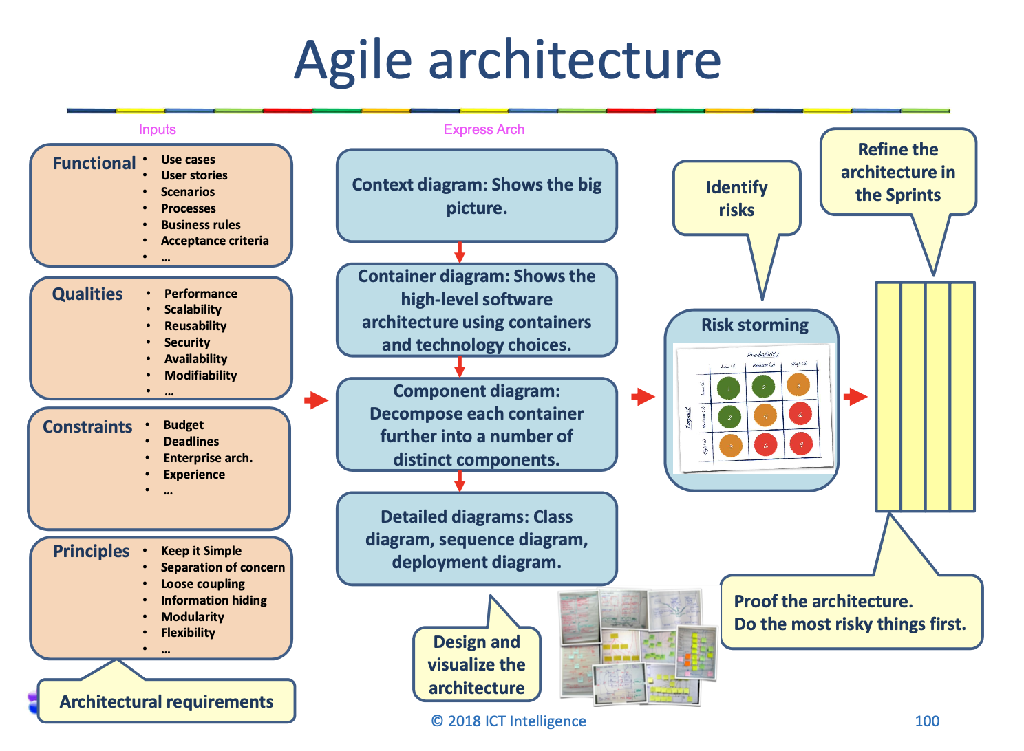

1 Software qualities  
 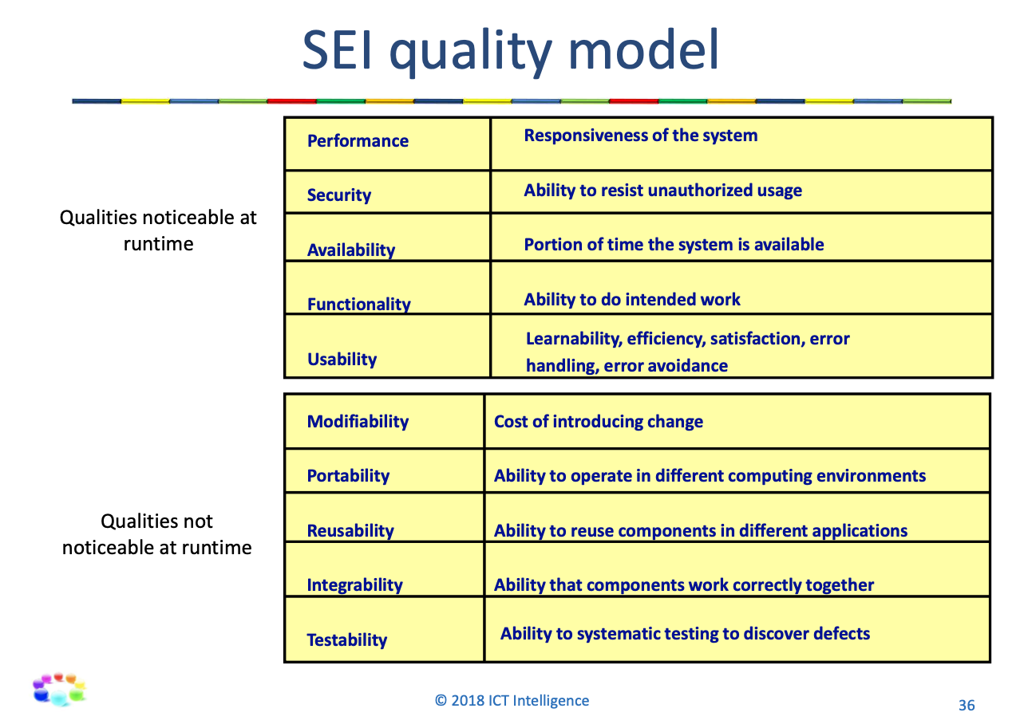

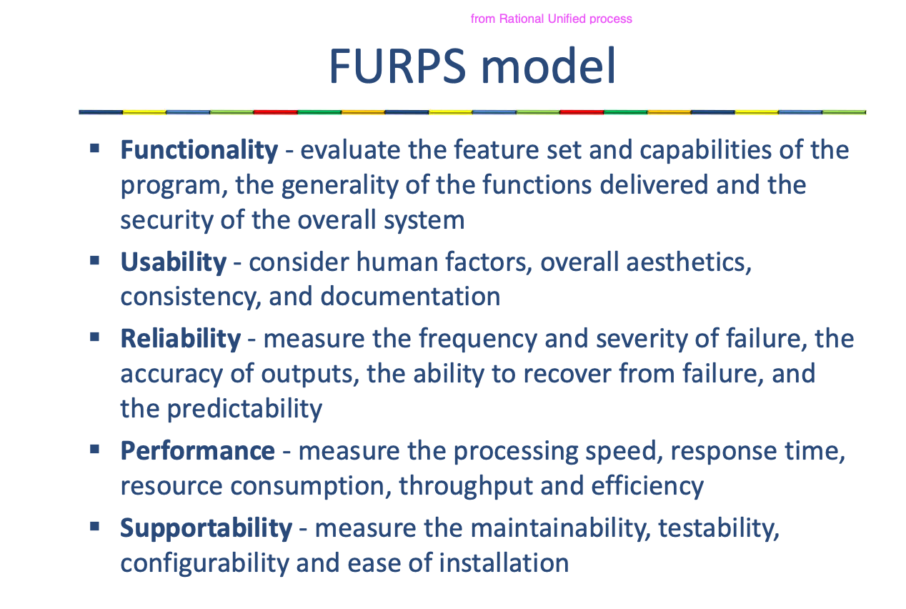

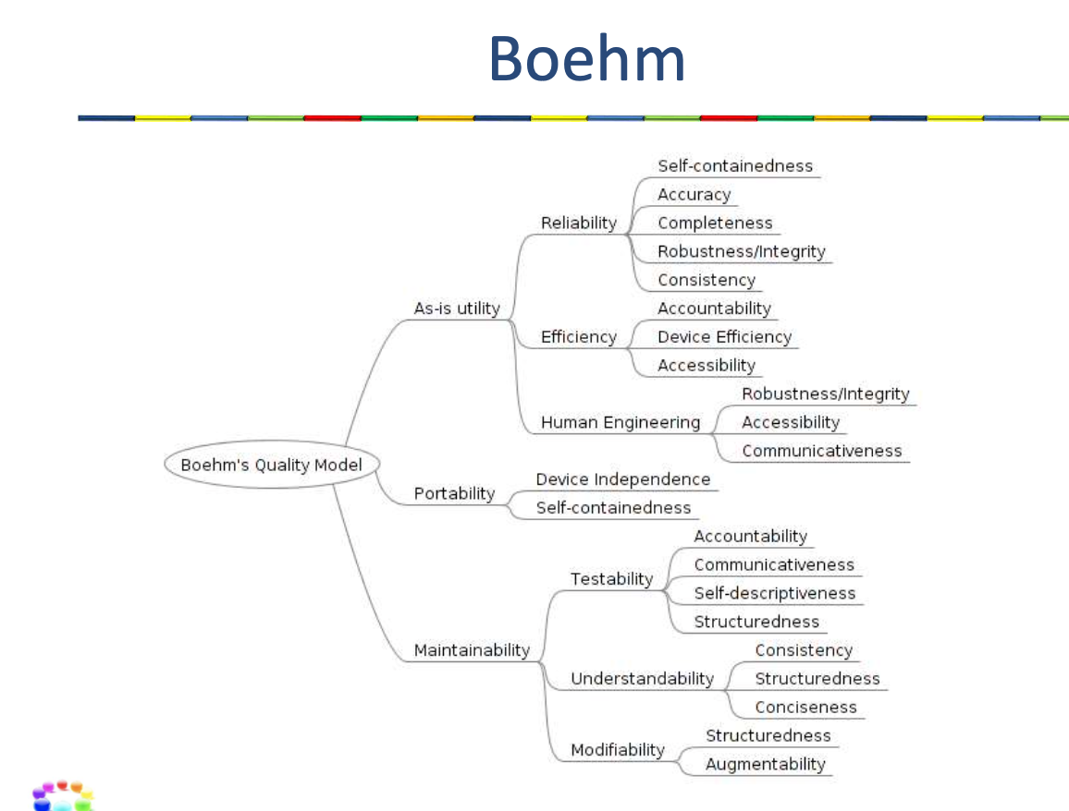

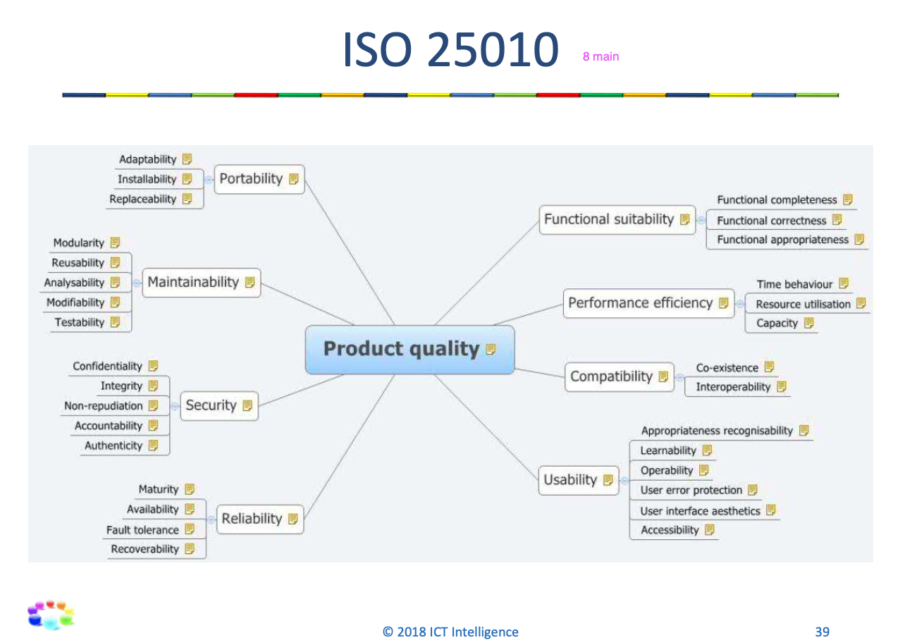

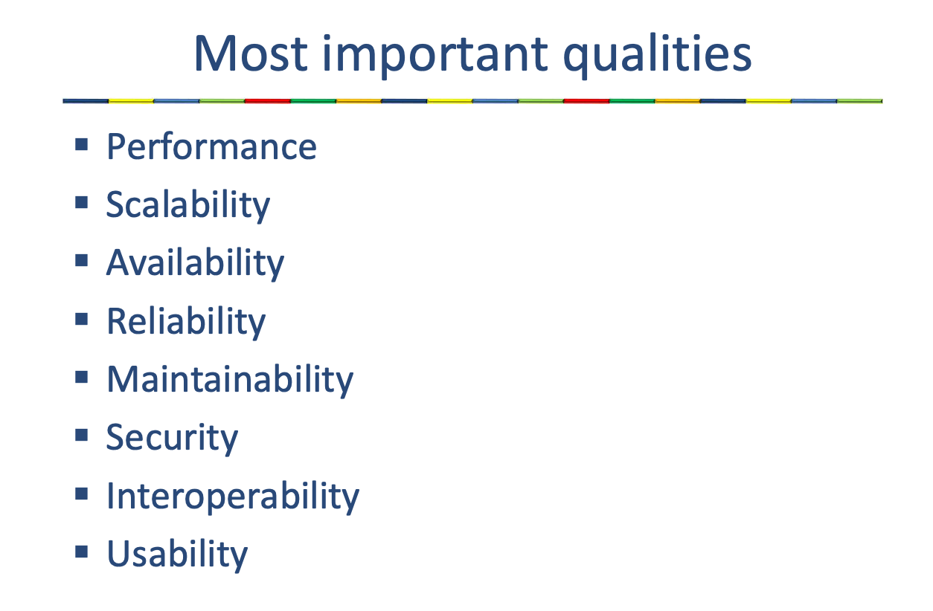

1 Architecture (design) principles

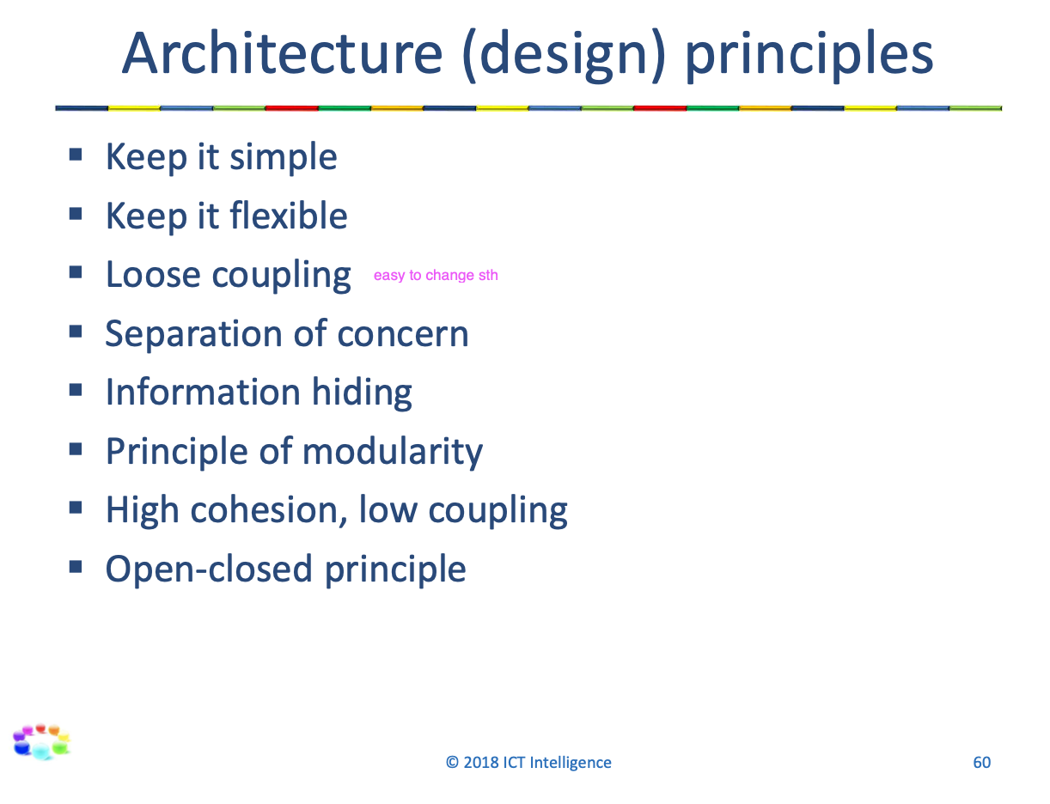

1 Communicating architecture

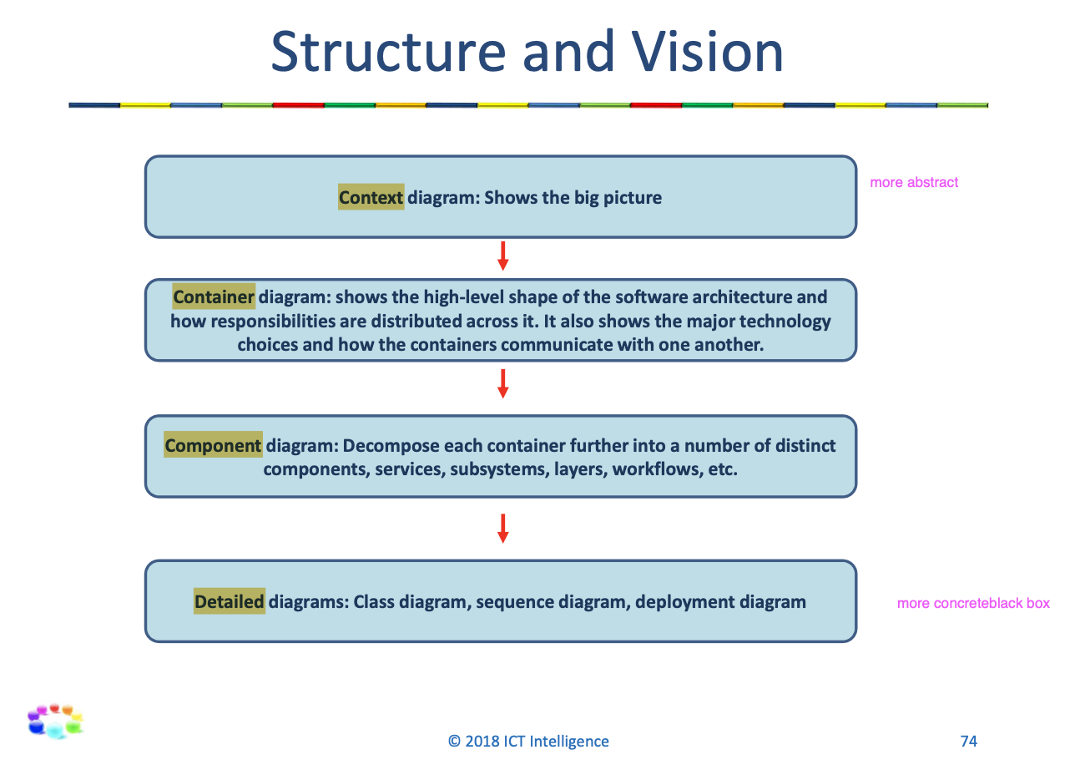

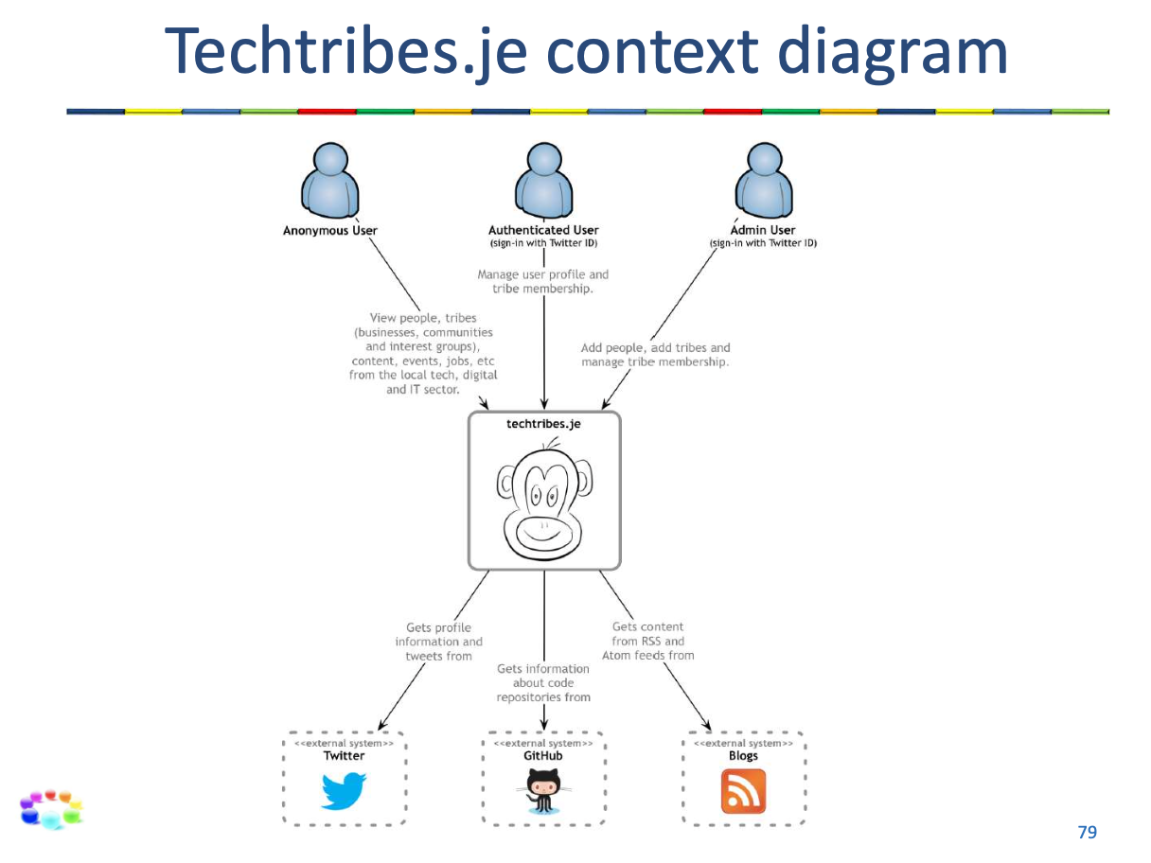

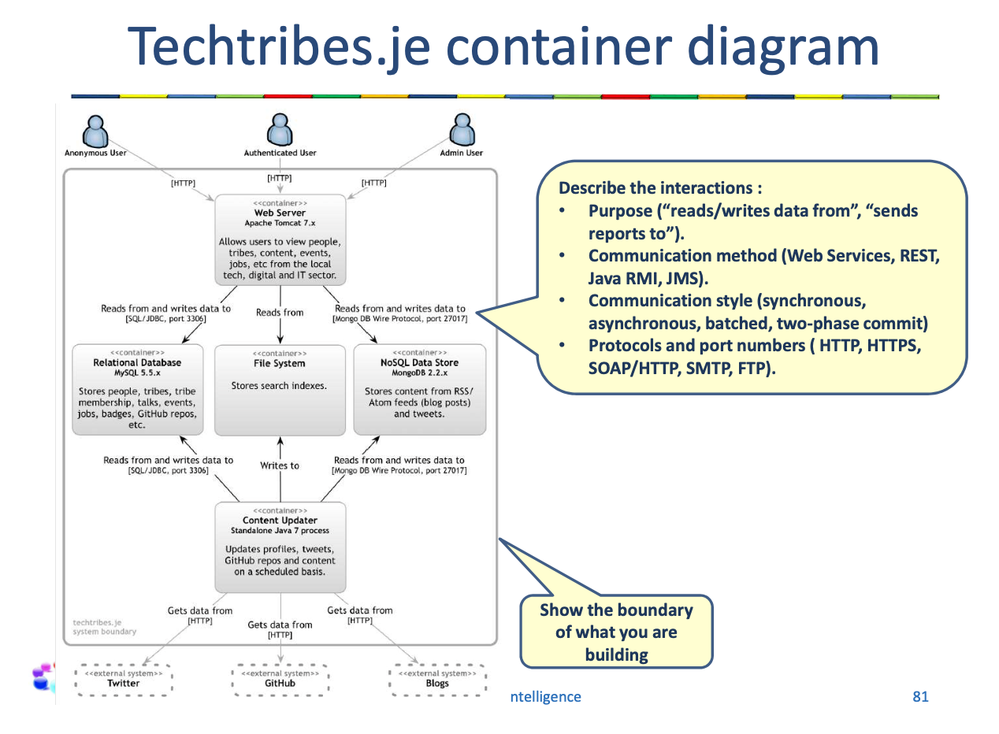

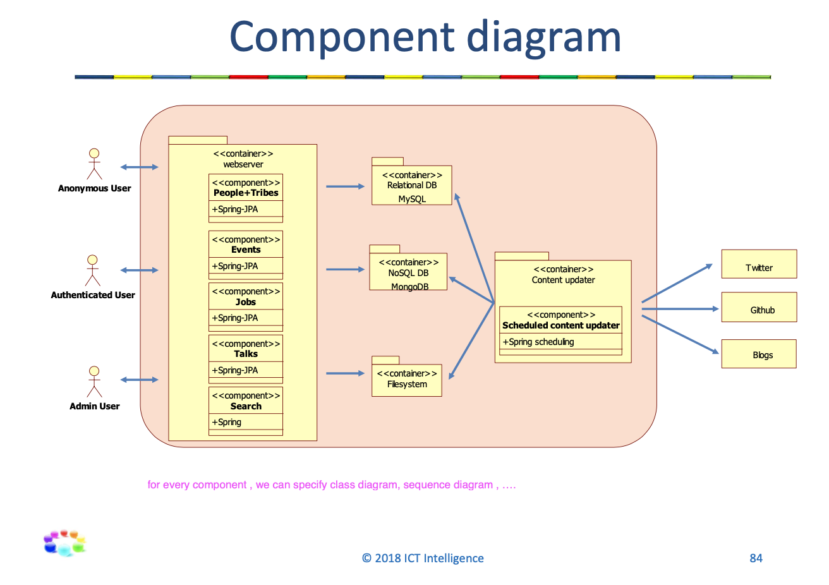

1 Identify risk: risk storming

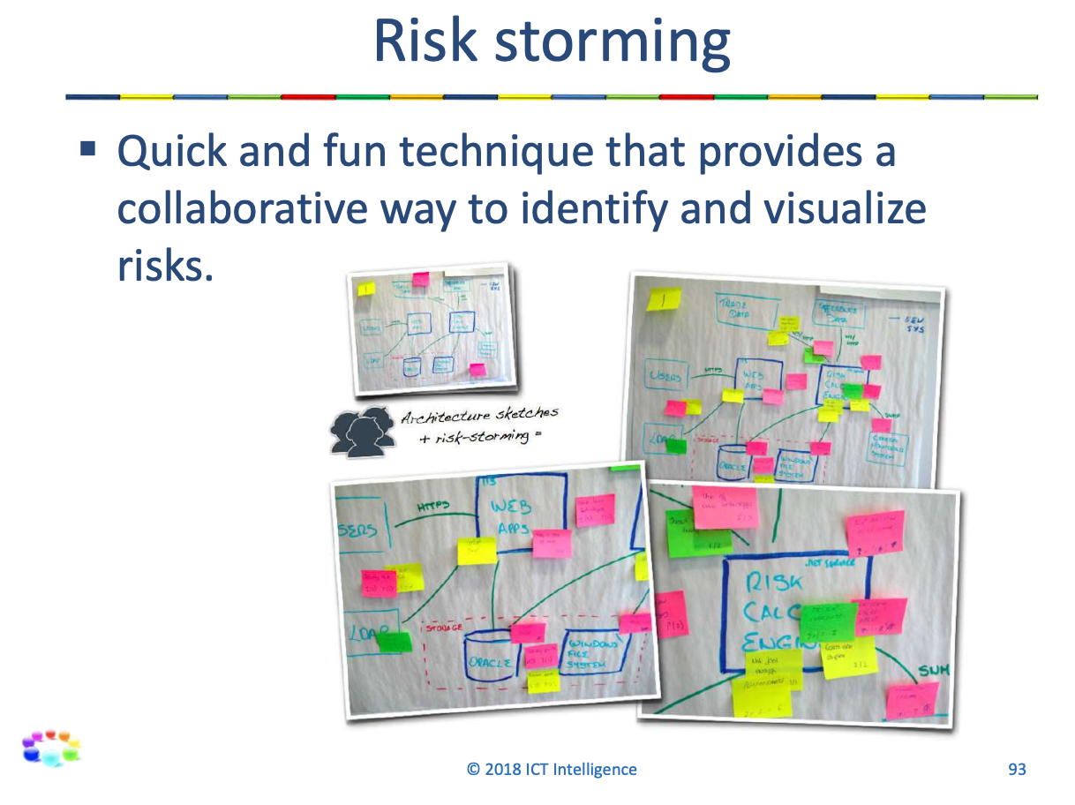

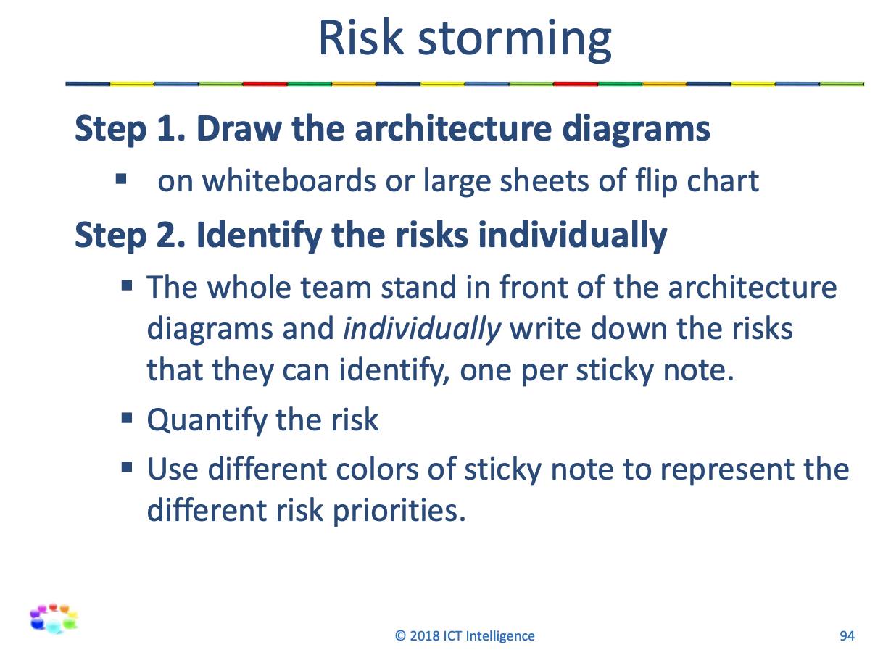

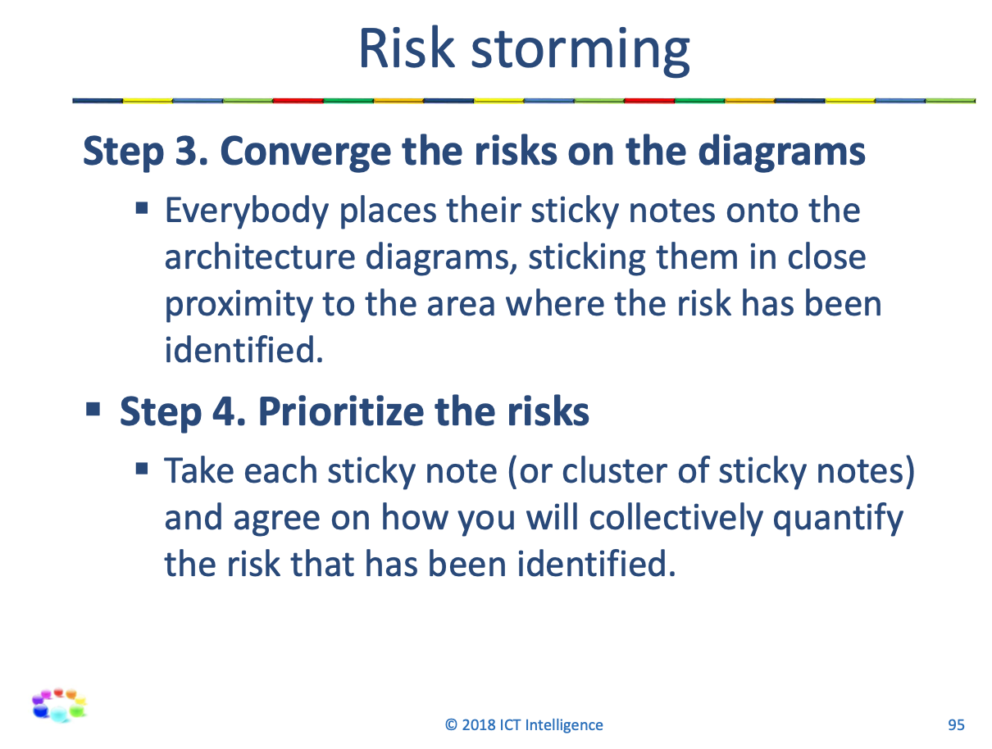

1 Clustering and Failover

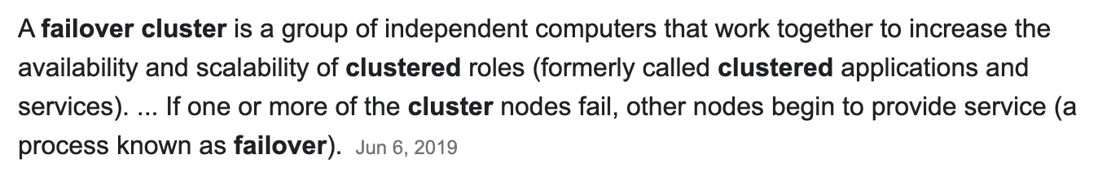

LESSON 2

2 Client-server

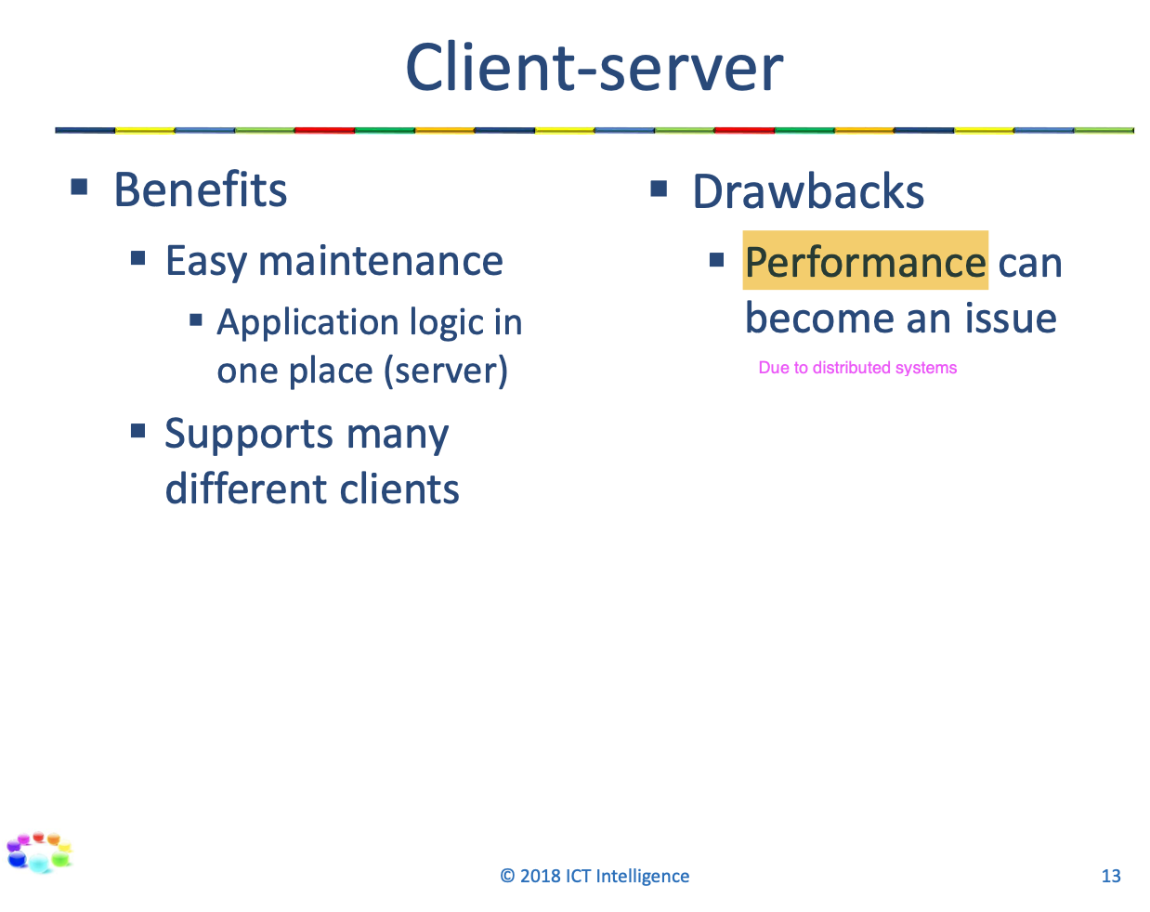

2 Layering

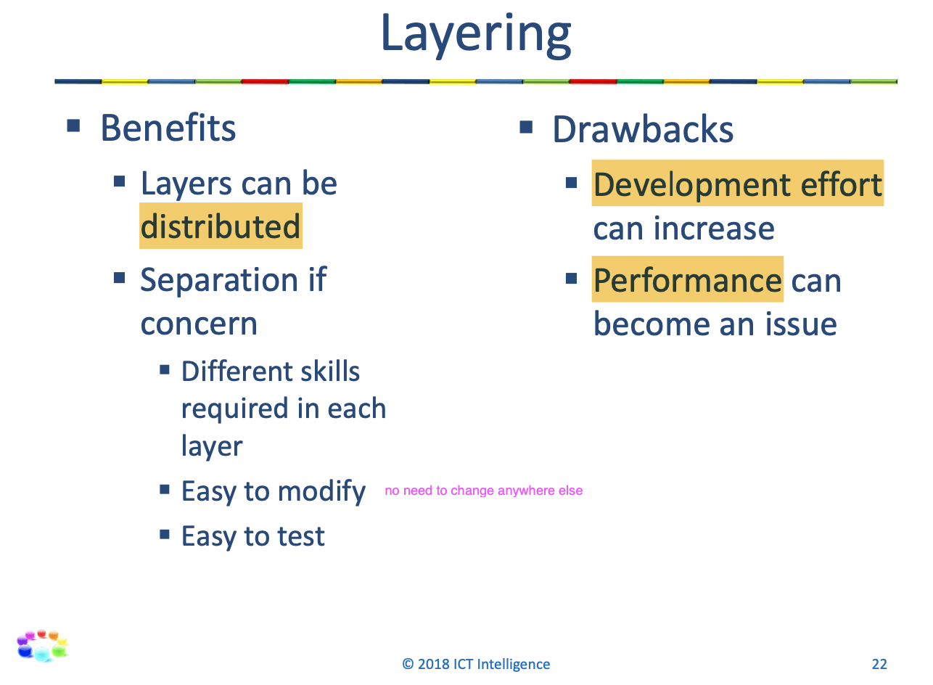

2 Pipe and filter

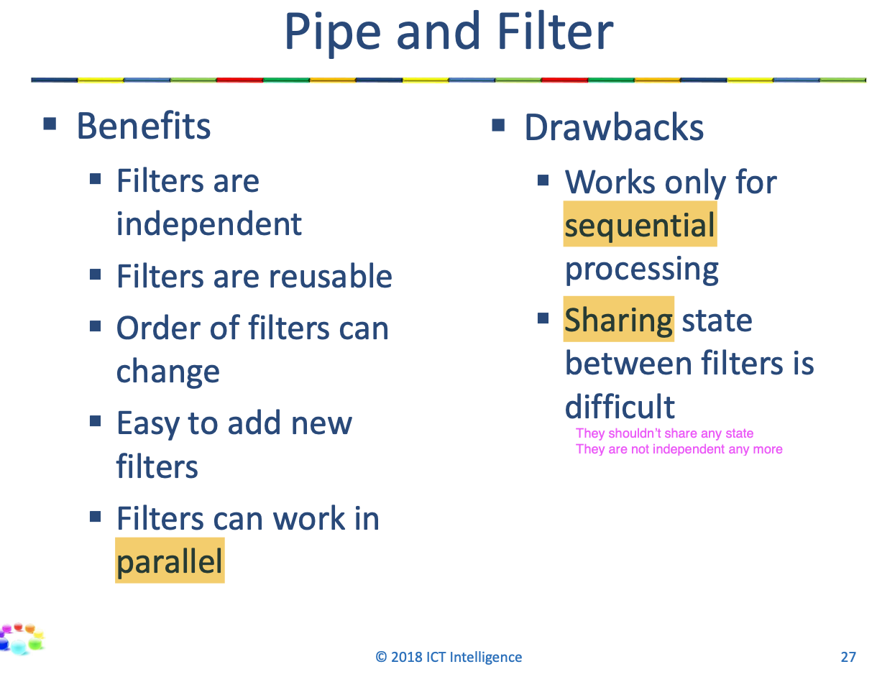

2 Master-slave

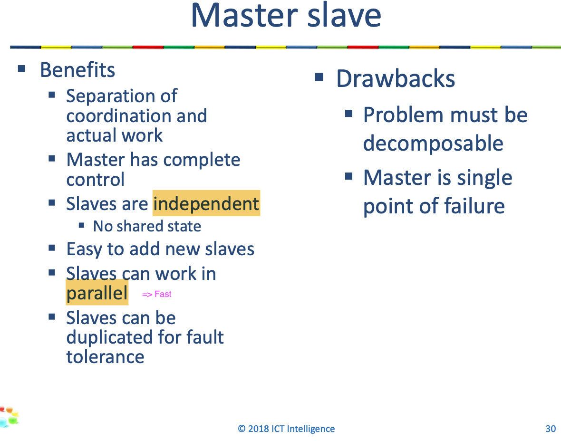

2 Microkernel

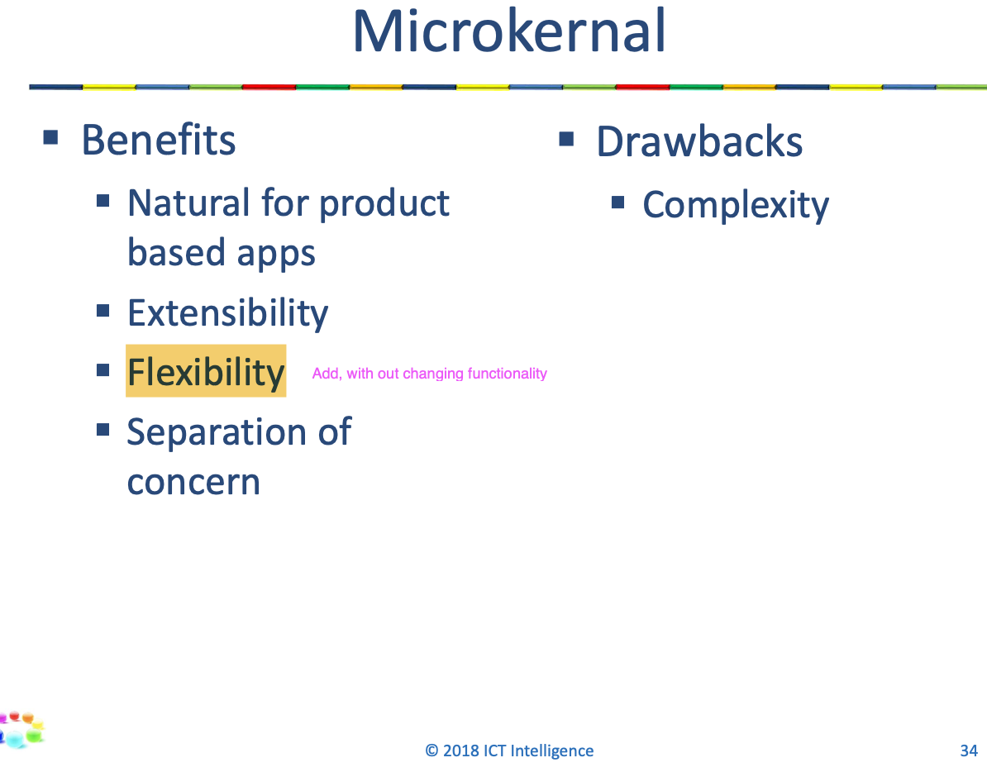

2 DOA/repository class

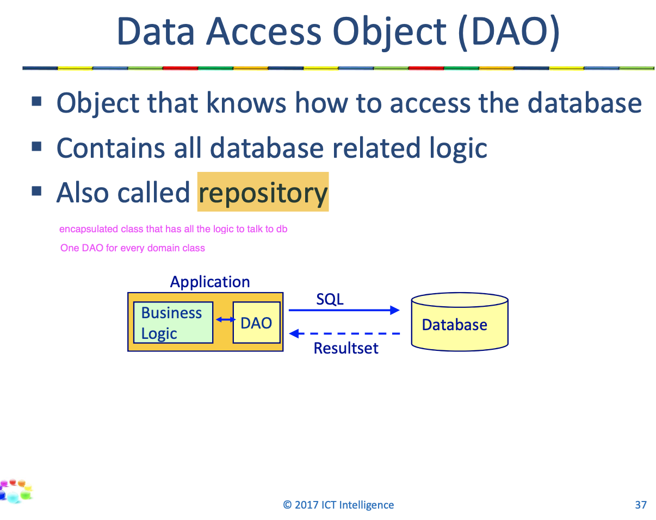

2 Service class

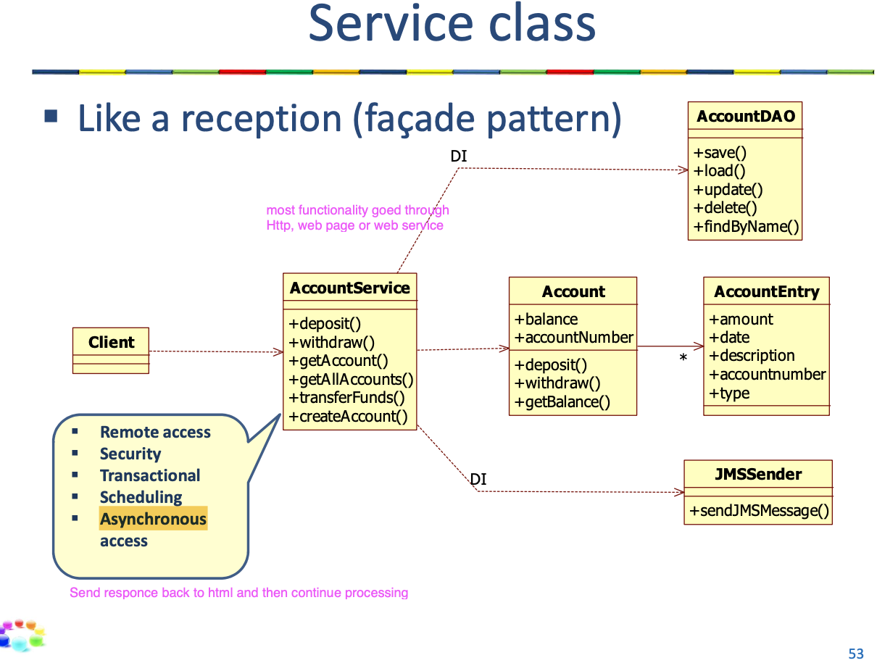

2 Proxy/Gateway class

2 Relational database versus NOSQL database

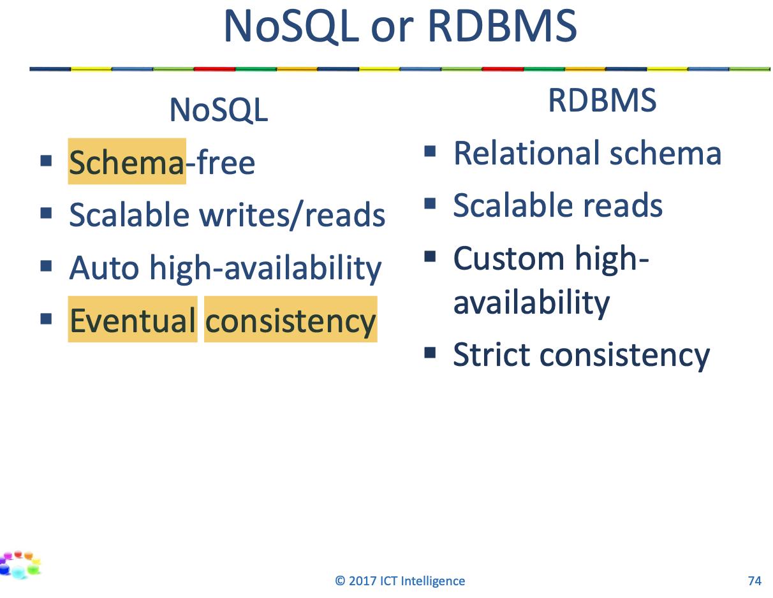

2 Scaling databases

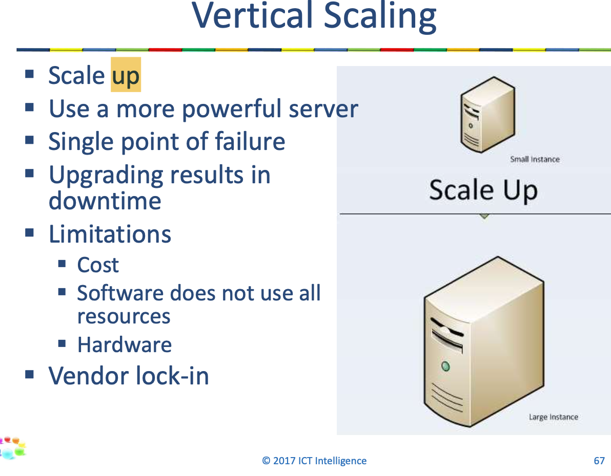

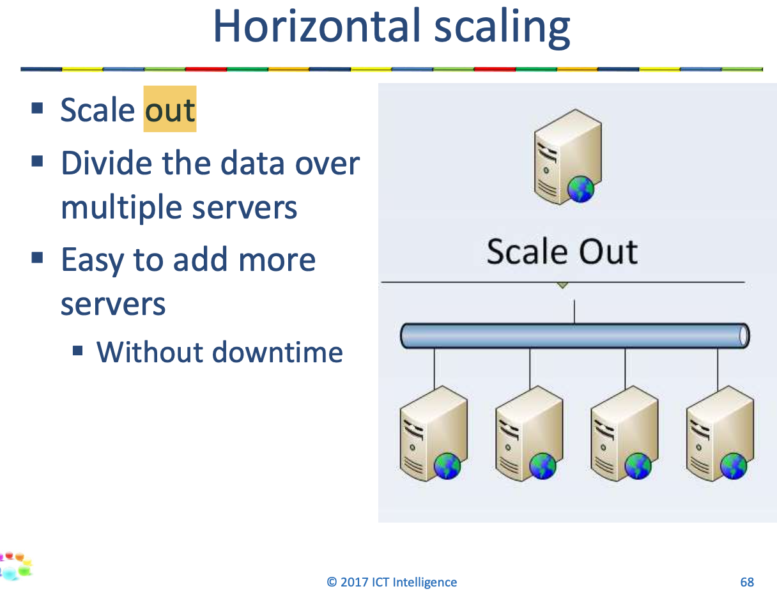

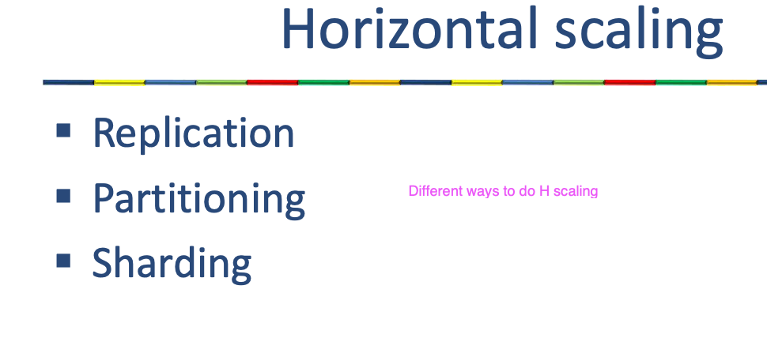

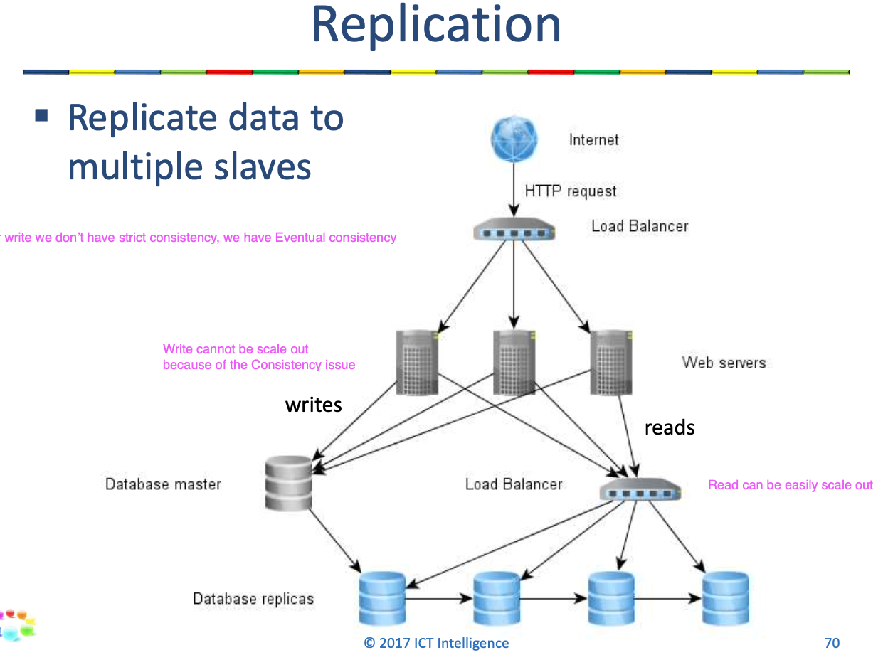

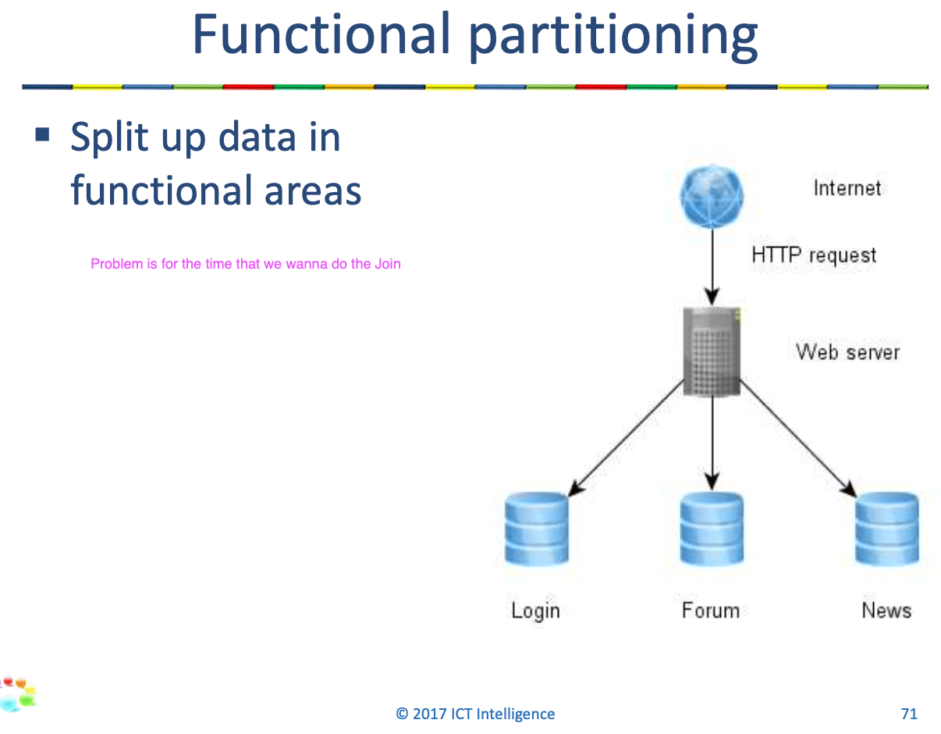

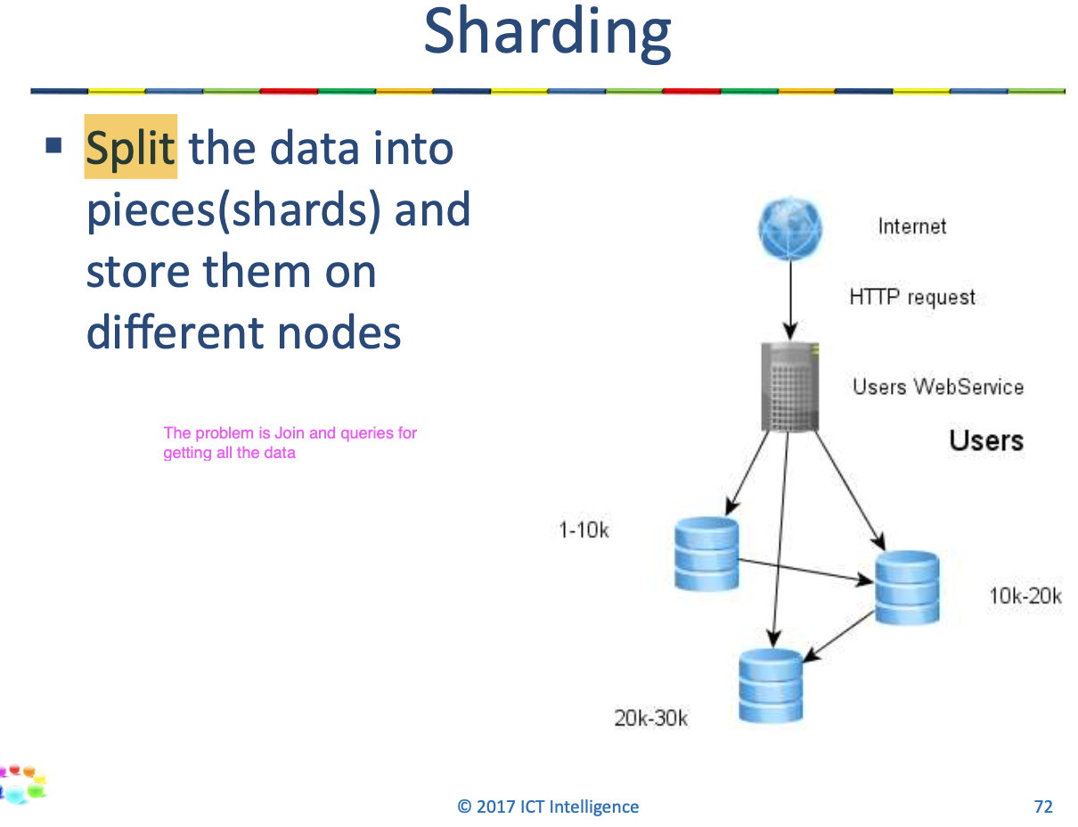

2 Brewers cap theorem

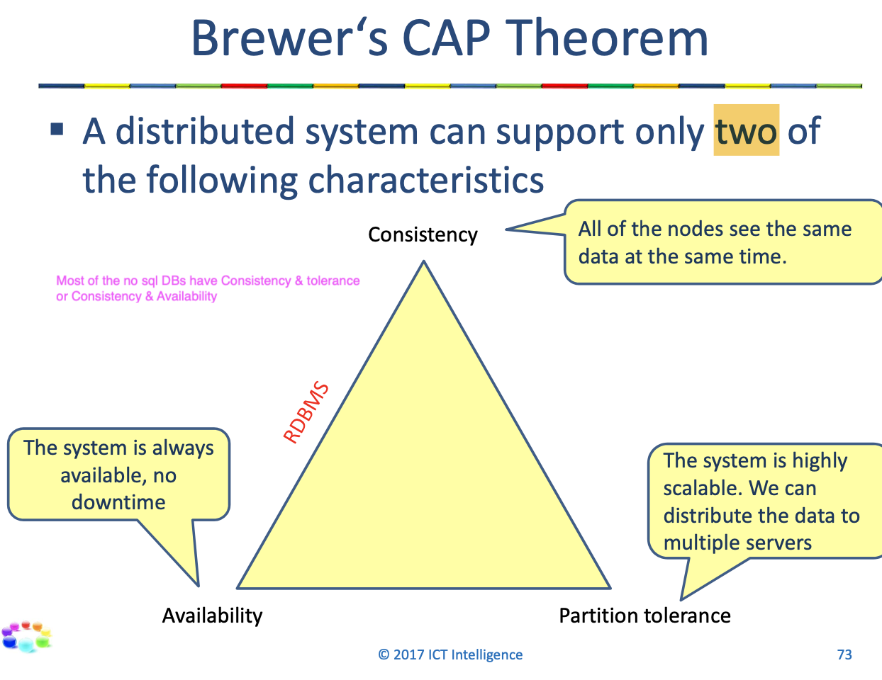

2 Strict consistency – eventual consistency

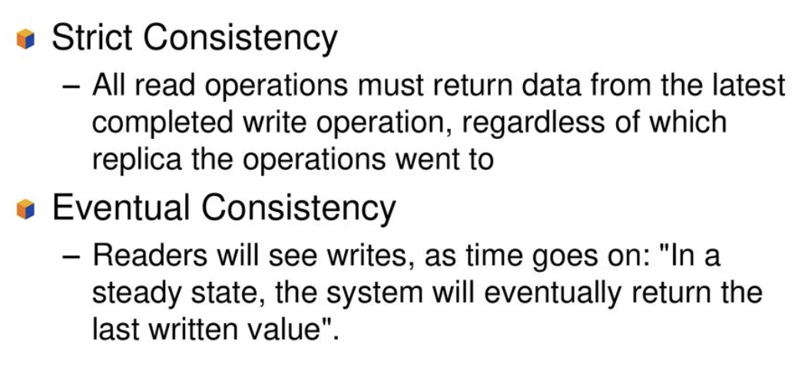

LESSON 3

3 Dependency injection

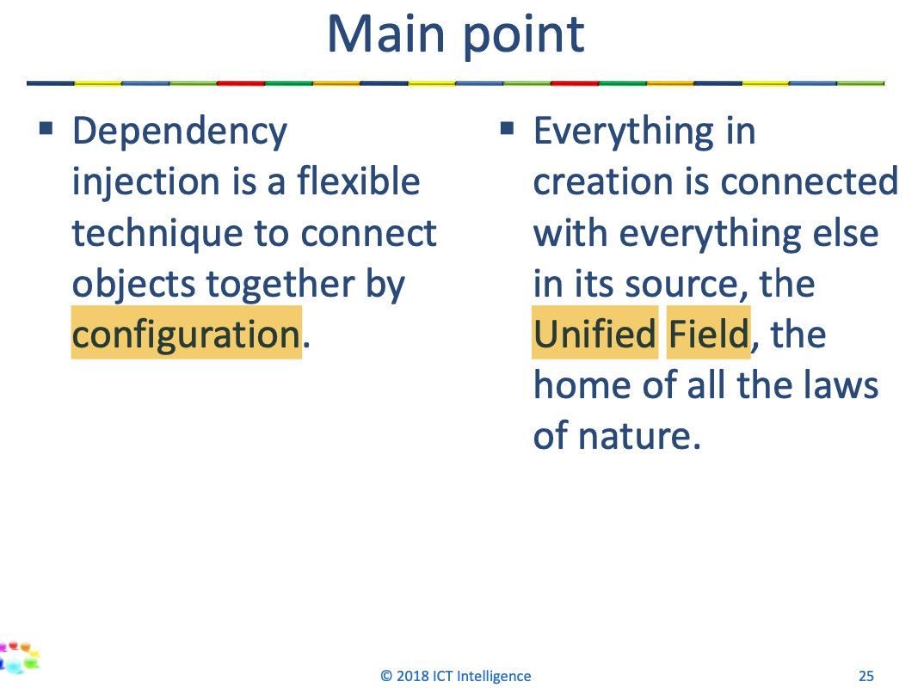

3 REST

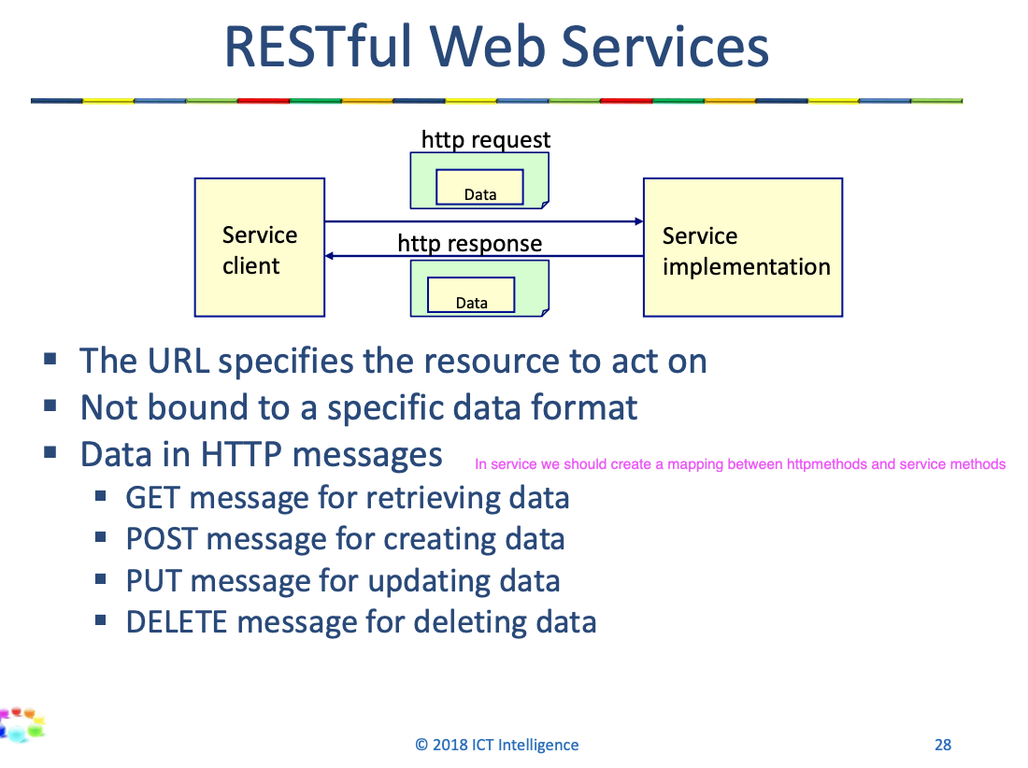

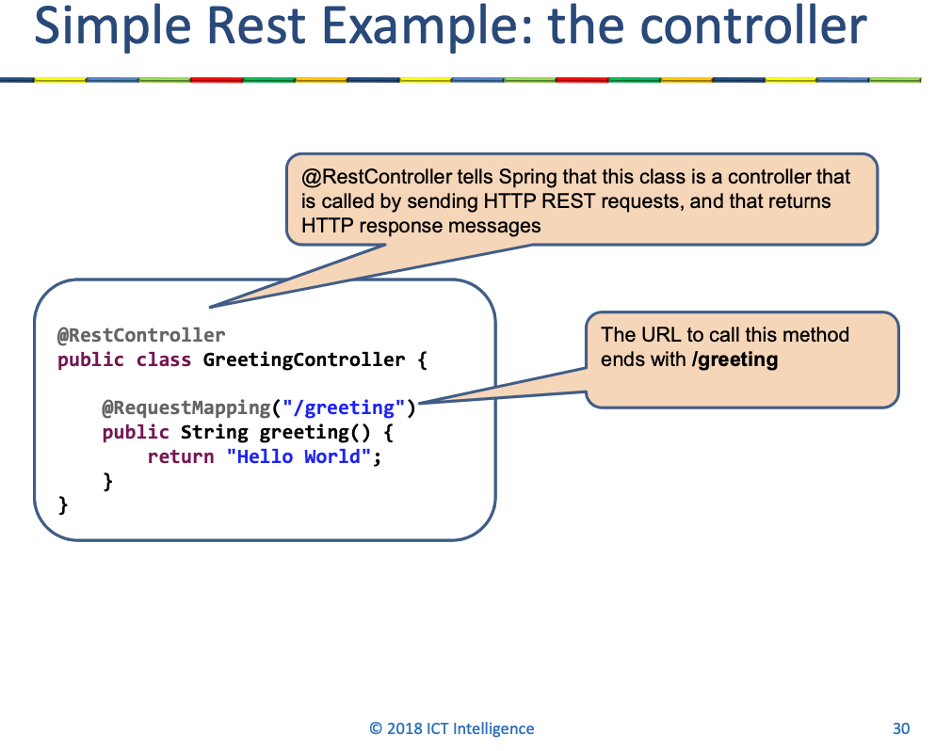

3 Mongo

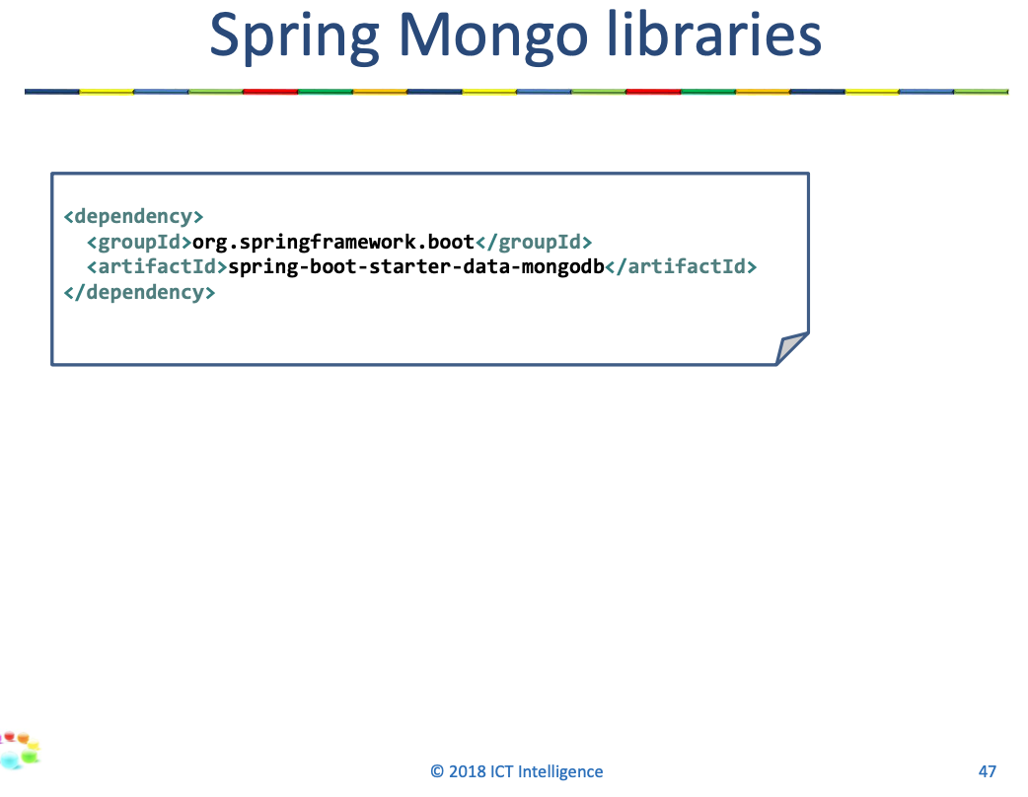

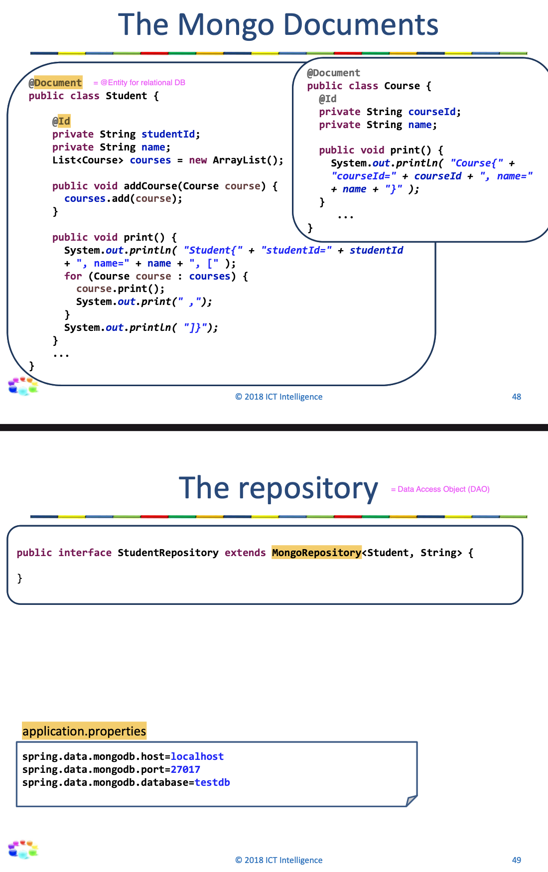

LESSON 4

4 Entity

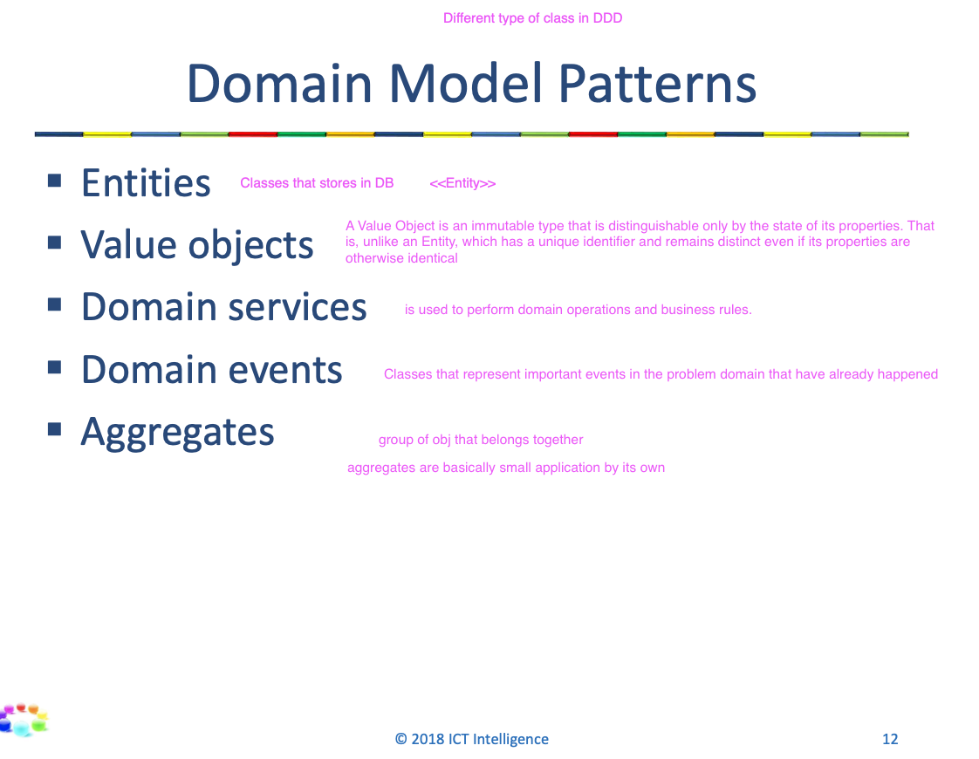

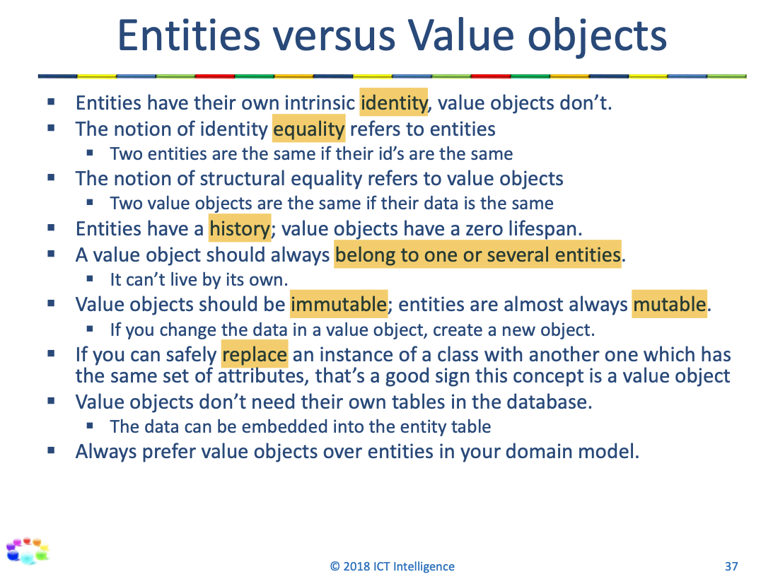

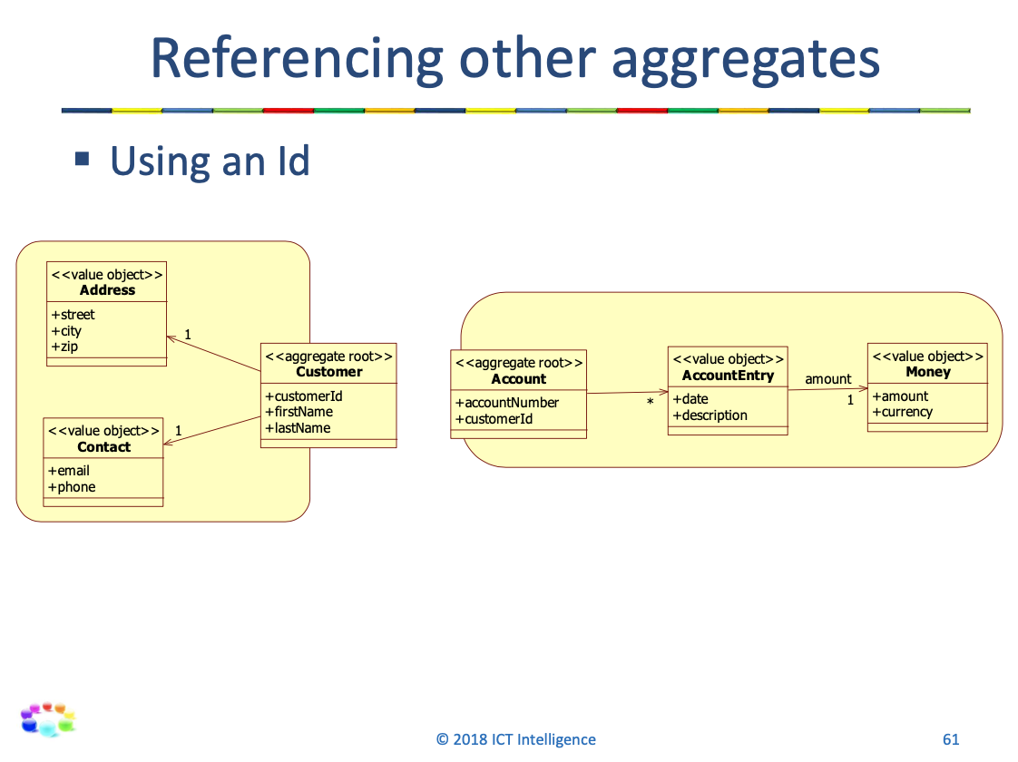

LESSON 5

5 Ubiquitous language

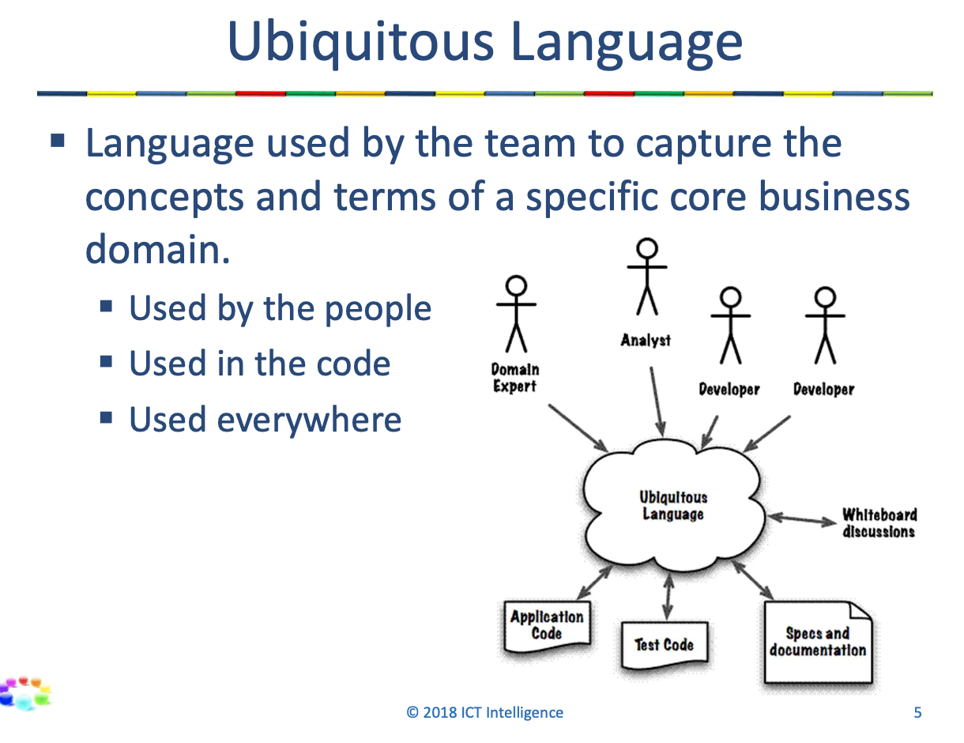

5 Rich domain model

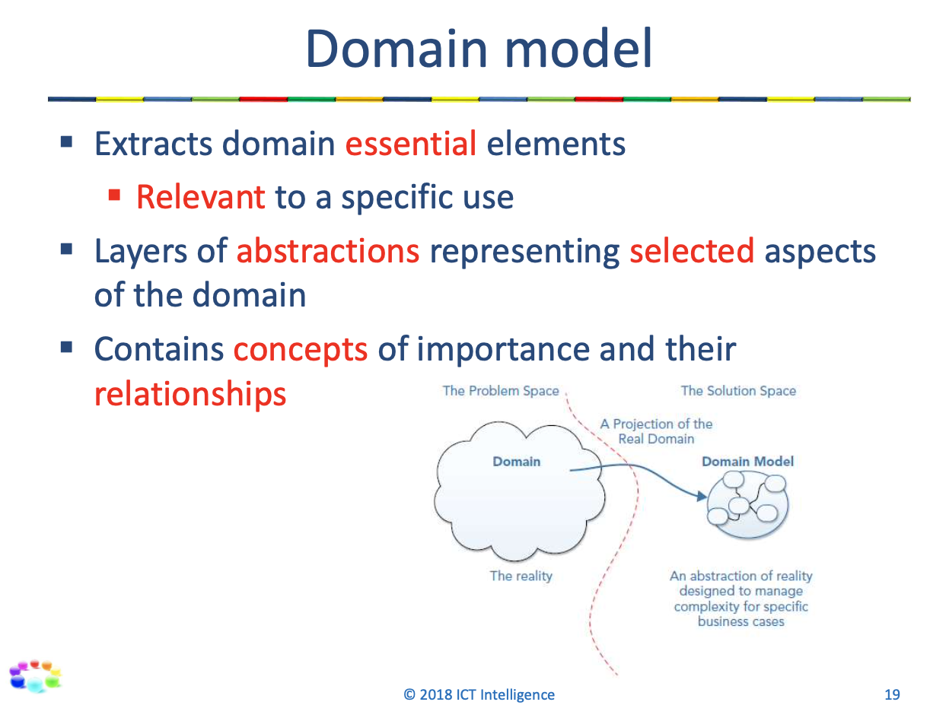

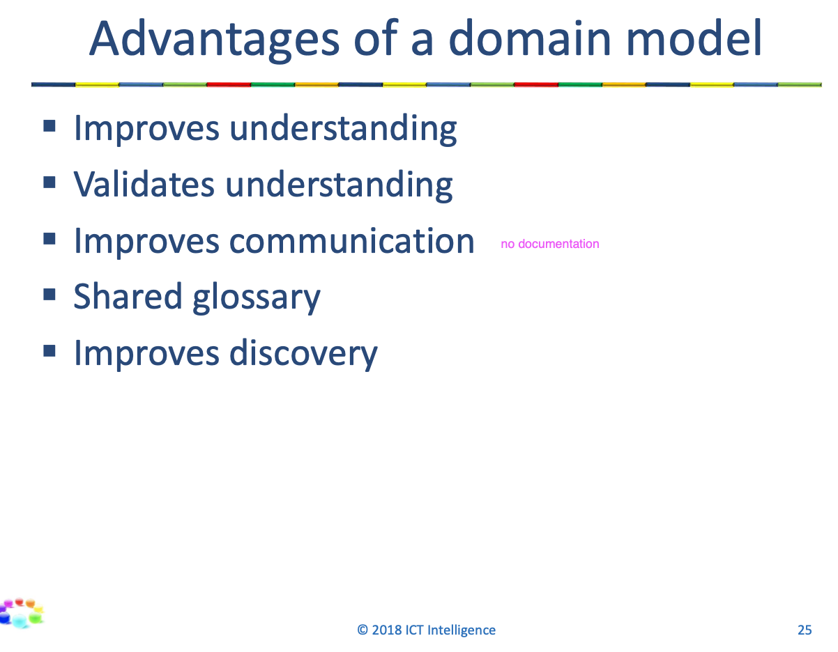

5 Bounded context

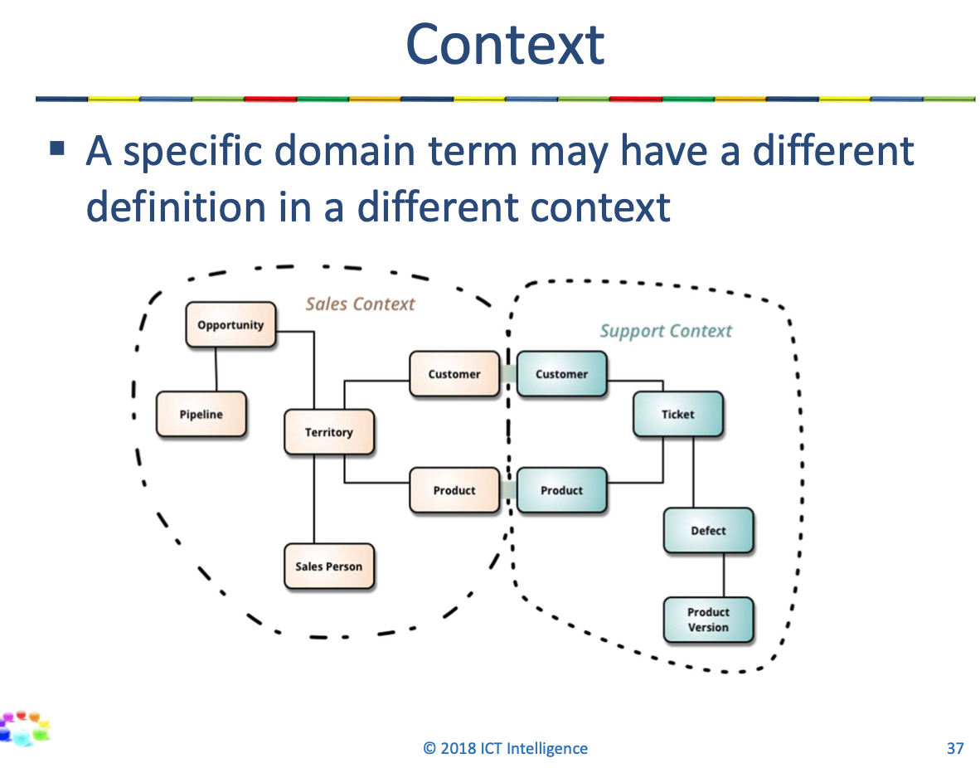

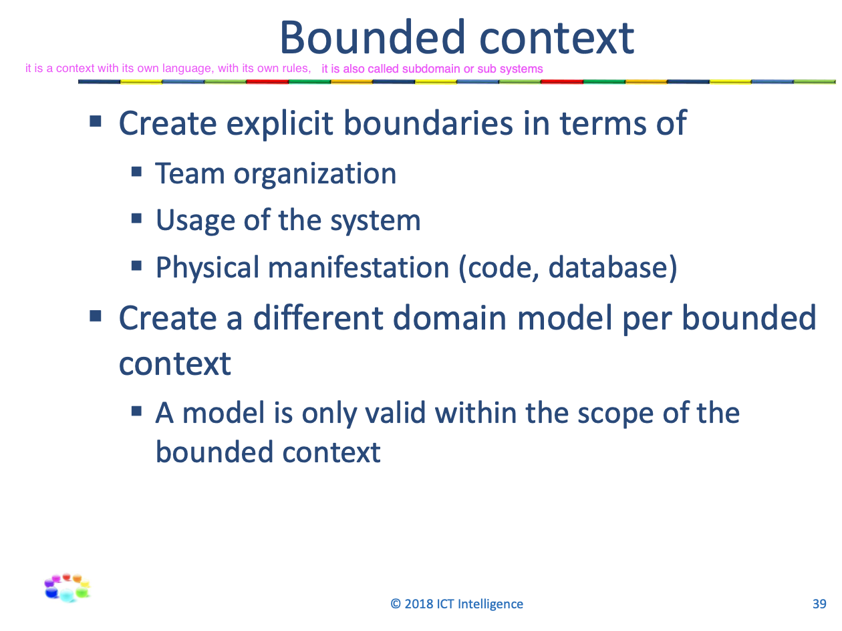

5 Components

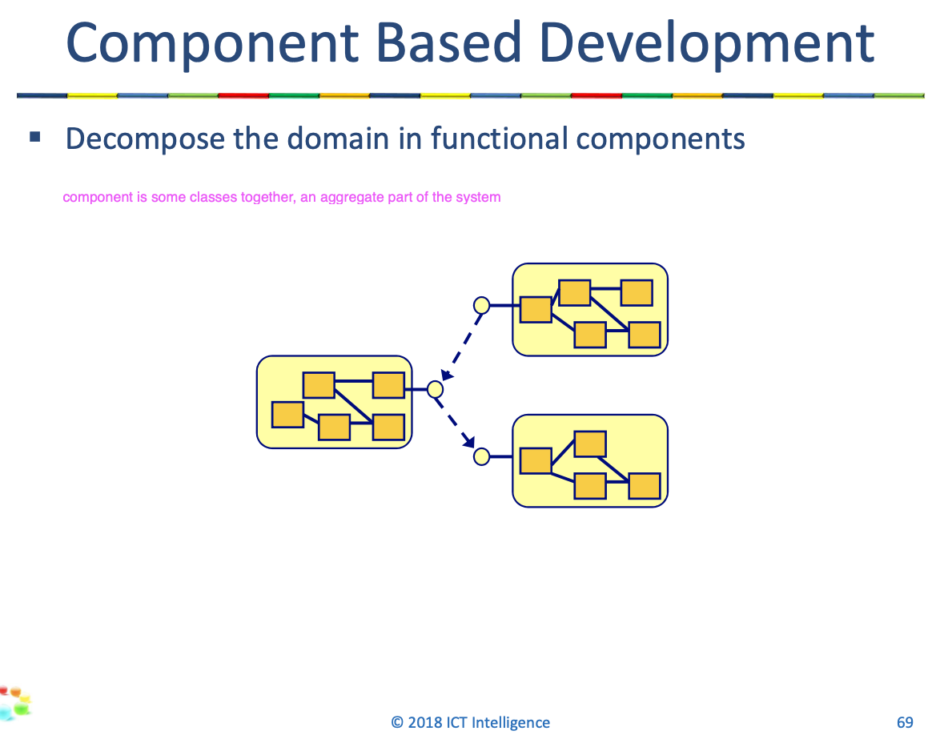

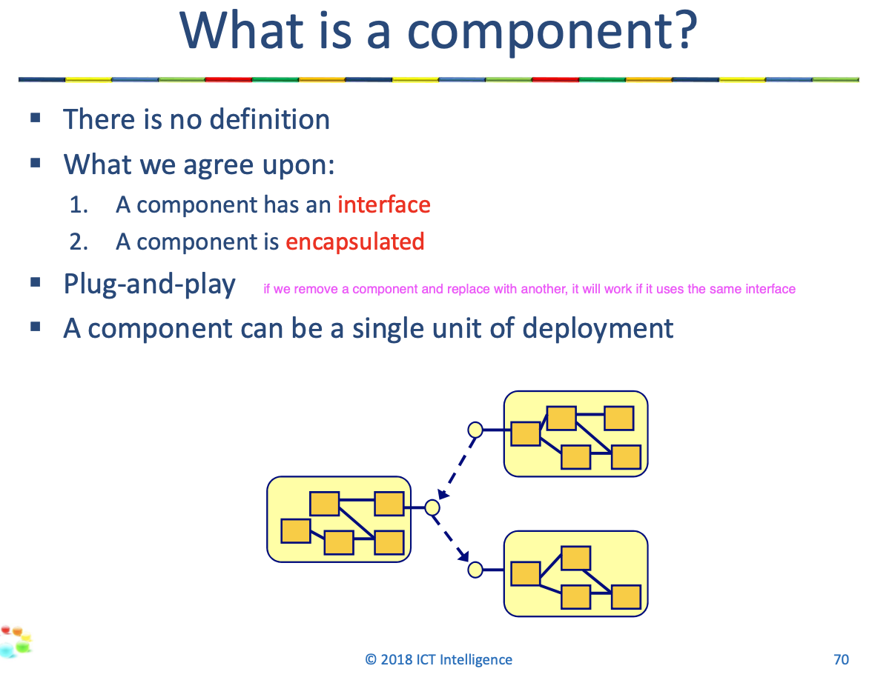

5 Interface design

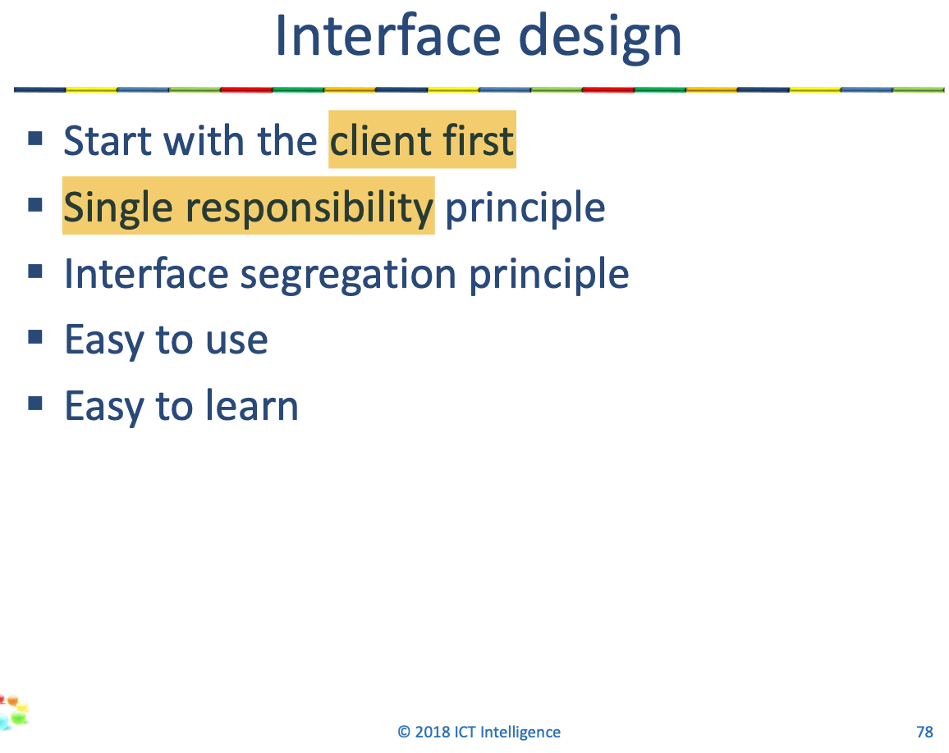

5 DTO’s

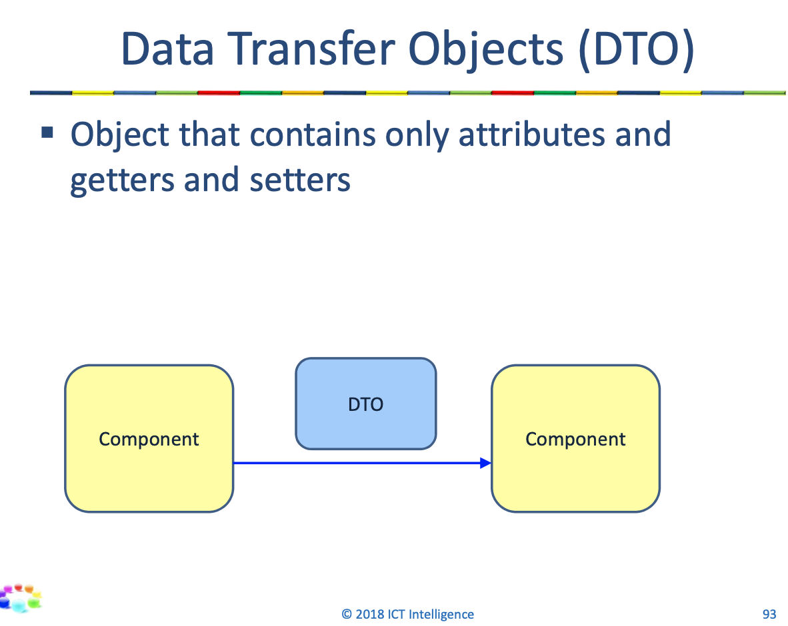

5 Adapter

5 Spring Events

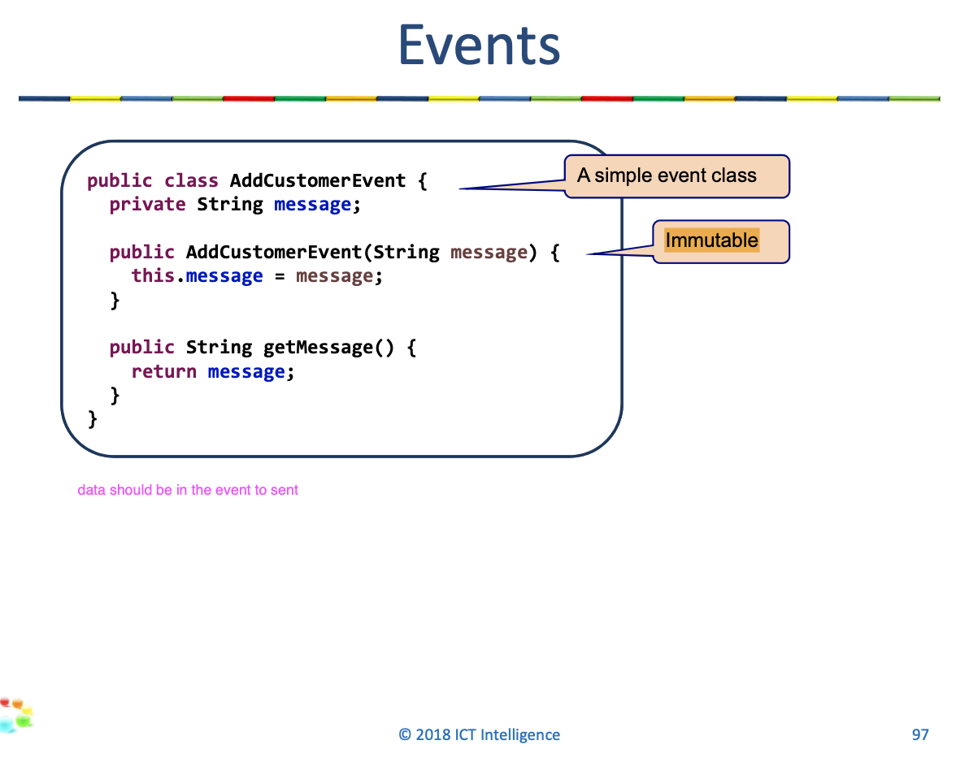

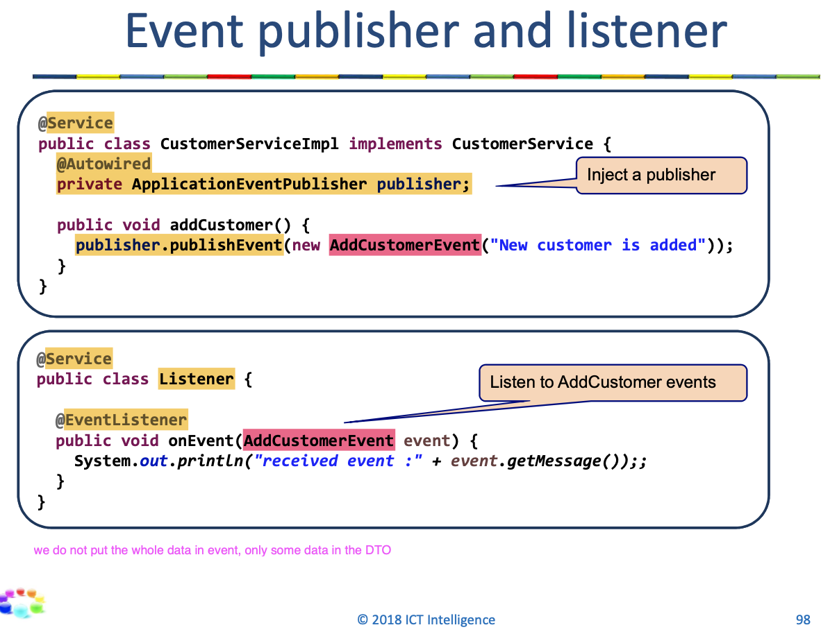

LESSON 6

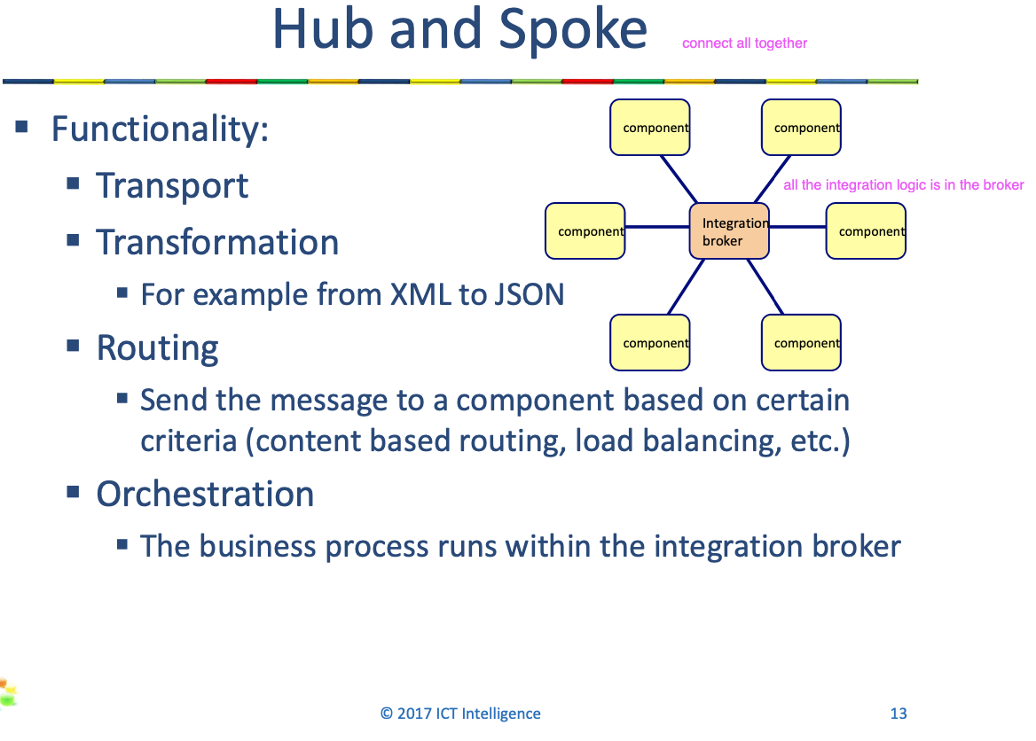

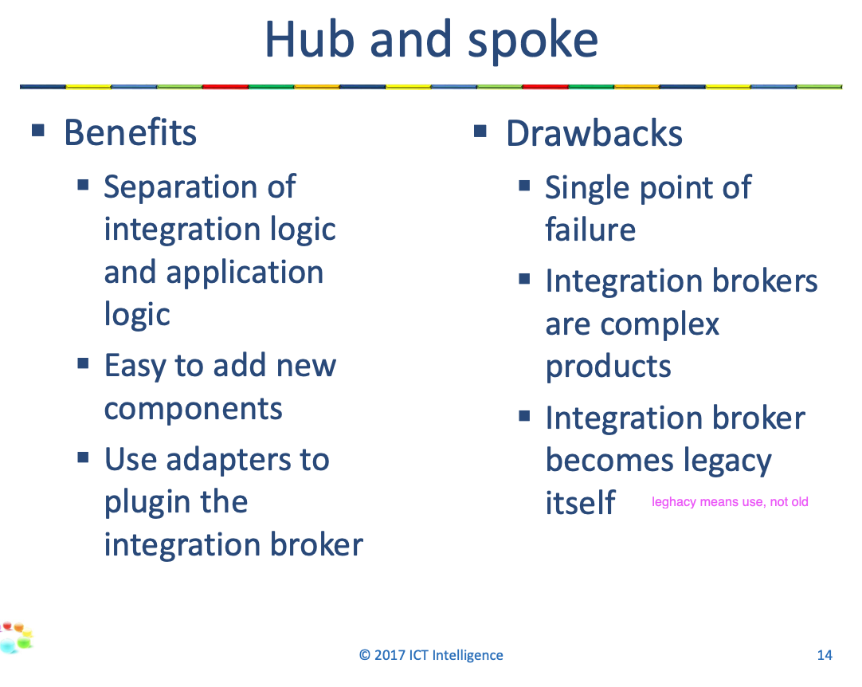

6 ESB

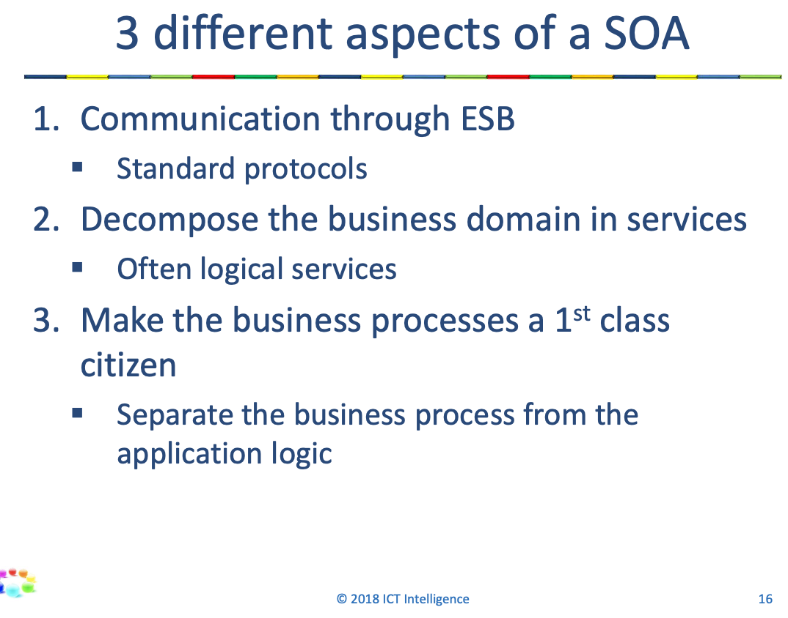

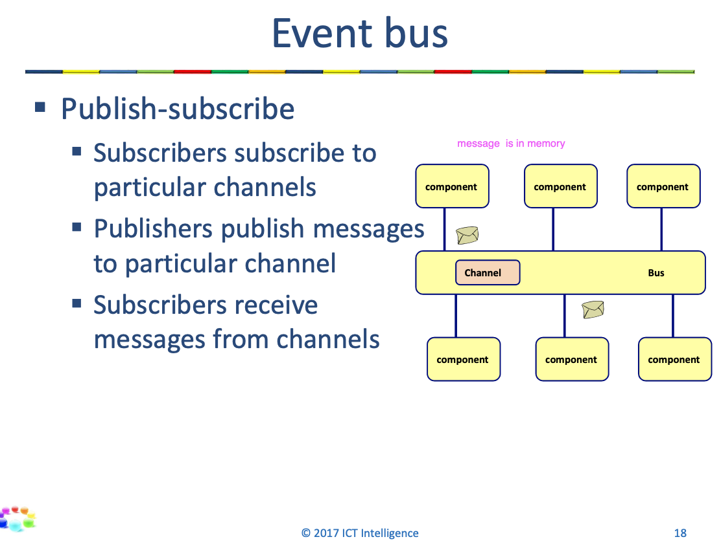

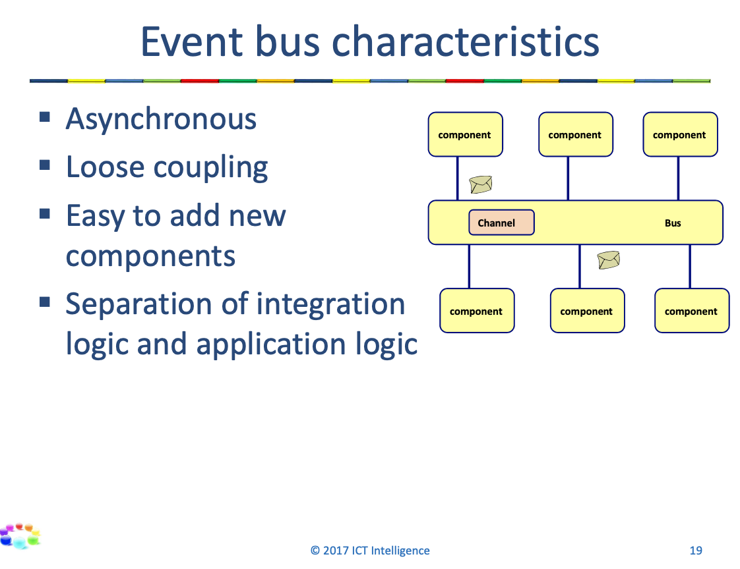

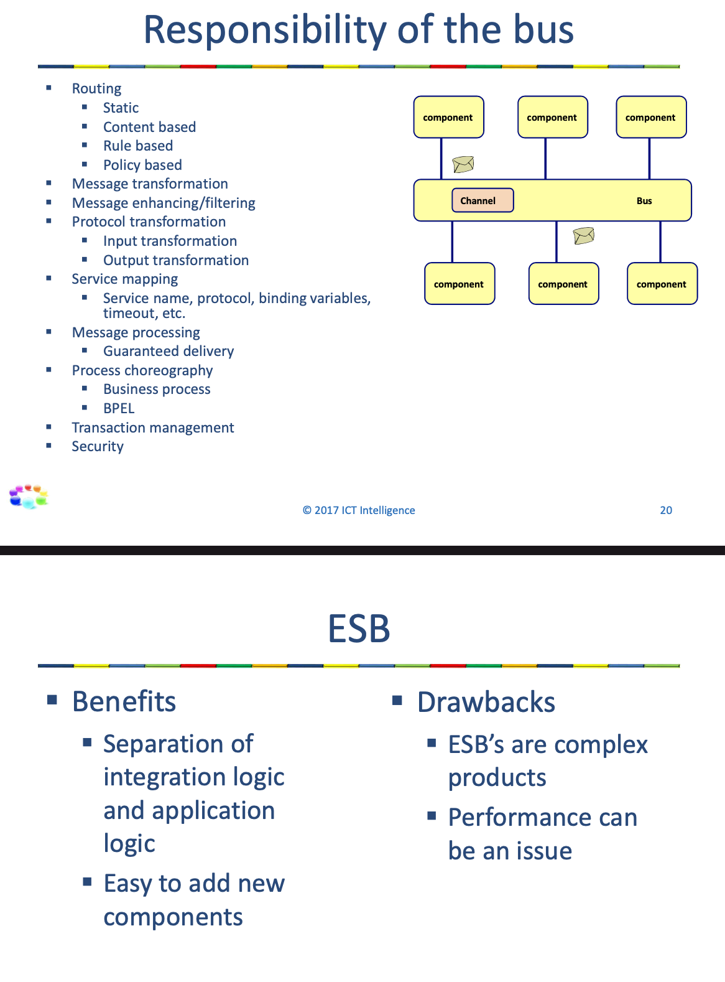

6 Integration patterns

* Messaging channel patterns
  + Point-to-point: only one receiver will receive the message
  + Publish-Subscribe: every subscriber will receive the message
  + Datatype Channel: use a channel for each data type, so that the receiver knows how to process it
  + Invalid Message Channel: for messages that don’t make sense for the receiver
  + Dead Letter Channel: for messages that can’t be delivered
  + Channel adapter: connect the application to the messaging system
  + Message bridge: connect 2 messaging systems
* Message construction patterns
  + Command message.- Send command as message succh as last trade price
  + Document message.- Doc with data as a message such as Order
  + Event message.- Event as message such as Price change event. Event =something that happened in the past, Cmmd => something need to happen
  + Request-Reply
  + Return address
  + Message expiration
* Message Endpoint
  + Event driven consumer
  + Polling consumer
  + Competing consumers
  + Message dispatcher
  + Durable and Non-Durable subscribers
  + Service activator
* Message Routing
  + Content based router
  + Dynamic router.- Dynamic router has some rules, knows when gets some thing , where should send to
  + Message filter.- It filter gadgets => just widget can continue
  + Recipient list.- contains the logic to where the message should be sent to the whole list of receivers
  + Splitter.- Split up the msg, you sent the order and get the order lines, most of the time you need to write logic
  + Aggregator
  + Sequencer
  + Composite Message Processor
  + Routing Slip .- specifying the sequence of processing steps.
* Message transformation
  + Envelope Wrapper
  + Claim Check
  + Normalizer
  + Canonical Data Model
* Management
  + Control Bus to manage an enterprise integration system.
  + Deteur
  + Wire tap
  + Message history
  + Message store
  + Test message

LESSON 7

7 ESB versus Integration Framework

